Geography – Climate Change

**The Evidence**

|  |  |  |  |  |  |
| --- | --- | --- | --- | --- | --- |
| Shrinking glaciers | Rising sea level | Seasonal changes | Ice core samples | Pollen analysis | Tree rings |
| This is when glaciers in cold areas of the world, such as Greenland, the Arctic, and Antarctic melt due to changes in the climate. Over the past 50 to 100 years, photographic evidence  has shown that the world's glaciers have been melting. | When the amount of water in the sea increases as a result of melting glaciers. The water that the glaciers melt into flows into the sea causing the sea levels to rise and could result in the flooding of low-lying land. Rising sea levels is also due to **thermal expansion**. Between 1901 and 2010, average global sea level rose by 0.19 m. | When the normal weather patterns and climate of a country changes and different seasons arrive later/ earlier. In recent years there have been signs of a seasonal shift - spring arrives earlier and winters tend to be less severe. These changes affect the nesting and **migration patterns** of wildlife. | Ice sheets are made up of layers of ice – one layer is formed each year. Scientists drill into ice sheets to get long cores of ice. By **analysing the gases** trapped in the layers of ice, they can tell what the temperature was each year – they can go back over the last **400,000 years**. The remains of organisms found in cores taken from ocean sediments can also be analysed and these can extend the temperature record back at least 5 million years. | Pollen from plants gets preserved in sediment and Scientists can identify and date pollen to show which species where living at the time. Scientists know the conditions that plants live in now, so preserved pollen from similar plants show that climate conditions were similar. | As a tree grows it forms a new ring each year – the tree rings are thicker in warm, wet conditions. Scientists take cores and count the rings to find the age of a tree. The thickness of each ring shows what the climate was like. Tree rings are a reliable source of climate change for the **past 10,000 years.** |

**The Quaternary period**

The Quaternary period is the most recent geological time period, spanning from about 2.6 million years ago to the present day.

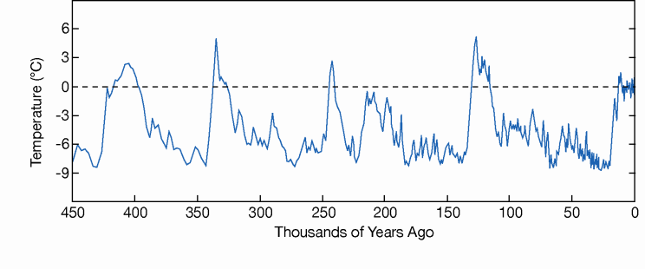

During the Quaternary period, there have been many repeating **glacial-interglacial cycles** (at least 20), when the global temperature shifted between cold glacial periods that last for around 100,000 years and warmer interglacial periods that last for around 10,000 years.

Global warming is the term used to describe the sharp rise in global temperatures over the last century – it is a type of climate change.

Natural Causes

**Volcanic activity** 🡪 Major volcanic eruptions eject large quantities of material into the atmosphere. Ash can shade the Earth, cooling it. Carbon dioxide is released during volcanic eruptions. Volcanic activity may cause short-term changes in climate e.g. The Earth cooled by about 0.5°C after Mount Pinatubo erupted in 1991.

**Solar Output** 🡪 The Sun’s energy output is not constant – it changes in short cycles of about 11 years, and possible cycles hundreds of years long as well. Reduced solar output means there are fewer **sunspots**, and that the Earth’s climate may become cooler in some areas.

**Orbital changes** 🡪 Orbital changes affect how much solar radiation the Earth receives. **Stretch** is that the Earth’s orbit around the Sun varies from circular to elliptical every 100,000 years (also called eccentricity). **Tilt** is that the Earth’s axis is tilted at an angle as it orbits the Sun. **Wobble** is that the Earth’s axis wobbles like a spinning-top (also called precession). These changes may have caused the glacial and interglacial cycles of the Quaternary period.

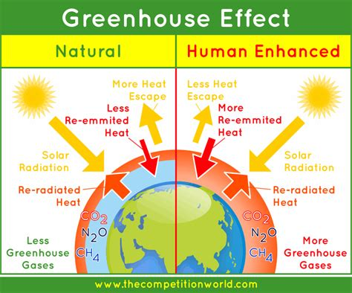

Human Causes

There is a scientific consensus that human activity is causing global warming through the greenhouse effect. The greenhouse effect takes place when greenhouse gases, such as **carbon dioxide**, **methane**, **CFC’s**, **water vapour** and **sulphur/nitrous oxides** absorb outgoing heat from the Earth. If greenhouse gas levels increase, more energy is trapped, and the planet warms up even more. Humans are increasing the concentration of these gases in the atmosphere through:

|  |  |  |  |
| --- | --- | --- | --- |
| Fossil Fuels | Deforestation | Agriculture | Cement Production |
| CO $_{2}$ is released into the atmosphere when fossil fuels like coal, oil, natural gas, and petrol are burnt, e.g., thermal power stations or cars. | Plants remove CO $_{2}$ from the atmosphere and convert into organic matter. When trees are burned CO $_{2}$ is released. | Farming livestock like cows produces a lot of methane and rice farming also because flooded fields emit methane. | Cement is made from limestone, which contains carbon. When cement is produced lots of CO $_{2}$ is released into the atmosphere. |

**Key Words**

**Mitigation** – managing causes of climate changing. This involves reducing greenhouse gas emissions and increasing the sinks for these gases.

**Adaption** – adapting to change in climate. This involves changing lifestyles to cope with the consequences of climate change.

**Climate change** – Any change in global temperatures and precipitation (rainfall) over time, due to natural or human activity.

**Glacial and Interglacial period** – An interglacial is a geological interval of warmer global average temperature lasting thousands of years that separates consecutive glacial periods within an ice age.

**Long wave earth radiation** – Radiation from the Earth that contains less energy than short-wave.

**Short wave solar radiation** – Radiation from the sun that contains more energy than long-wave.

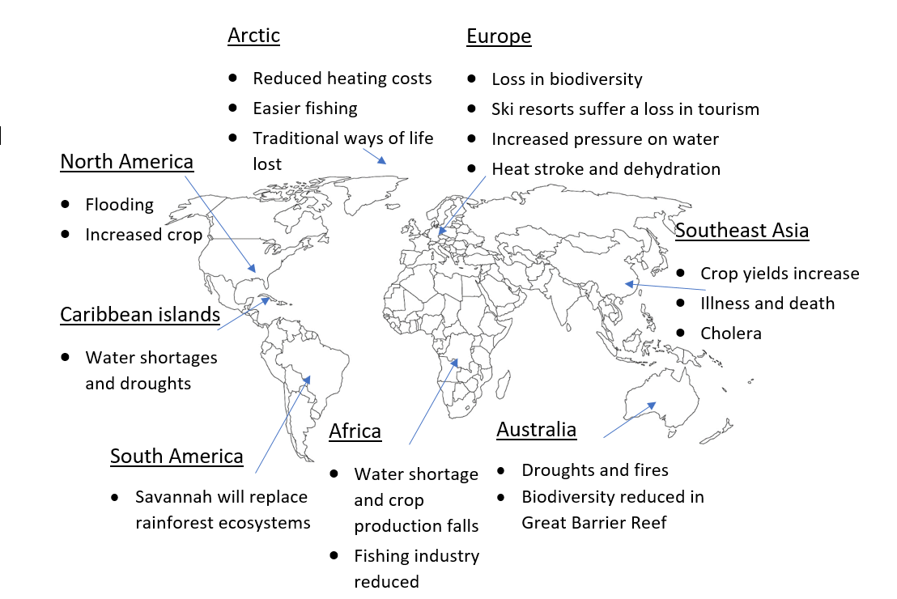

**Effects of Climate change**

|  |  |
| --- | --- |
| **Effect on Environment** | **Effect on People** |
| **Ocean acidification**, due to the high amounts of carbon dioxide in the atmosphere, is causing the disruption of marine life and may cause species to become extinct. | Some areas could become so hot and dry that they’re difficult or impossible to inhabit. Low-lying coastal areas e.g. the Maldives, could be lost to the sea or flood so often that they also become uninhabitable. This may lead to migration and overcrowding in other areas. Low-lying and coastal areas, like Miami and the USA, will also flood more regularly. |
| Sea ice is also shrinking, leading to the loss of polar habitats. | In some places, deaths due to **heat exhaustion** have increased – but deaths due to cold have decreased. |
| Costal erosion will increase with sea level rise and some coastal areas will be submerged, so habitats will be lost. | Problems with water supplies could lead to dehydration and to political tensions, especially where rivers cross borders. |
| Coral reefs like the Great Barrier Reef in Australia, are suffering from **coral** **bleaching** (rising sea temperatures makes coral expel the algae that lives in them). | Climate change is affecting farming in different ways: crops have suffered causing smaller yields in Argentina, but larger yields in Southeast Asia. Lower crop yields 🡪 illness and death from starvation |
| The distribution and quantity of some species could change, and biodiversity could decrease. For example, bamboo growth limited, leading to the decline in numbers of giant pandas. | More extreme weather means more money has to be spent on predicting extreme weather, reducing their impacts, and rebuilding after they take place. |

**Mitigation and Adaption**

|  |  |  |
| --- | --- | --- |
| Alternative Energy Production | Replacing fossil fuels with nuclear or renewable energy can help reduce greenhouse gas emissions. In the UK, more offshore windfarms are being built, e.g., in East Anglia, and several wave, tidal and nuclear power projects have been planned. However, these sources of renewable energy are expensive, more expensive than fossil fuels, so many large companies fuelled by fossil fuels are rejecting this idea. | |
| Carbon Capture and Storage (CCS) | Designed to reduce emissions from power stations burning fossil fuels. CCS involves capturing CO $_{2}$ and transporting it to safe places where it can be stored, for example deep underground. However, this again is extremely expensive, costing more than the factories itself, so many factories do not want this sort of technology due to its economical weight. Furthermore, we do not know the long-term effects of this technology on the ground, so it is unknown whether it does damage to the ground. | |
| Planting Trees | Trees are like carbon sinks or sponges which soak up the carbon dioxide in the atmosphere to fix it into organic molecules through carbon fixation. Planting trees increases the amount of CO $_{2}$ that is absorbed from the atmosphere through photosynthesis. The only disadvantage to this strategy of mitigation would be that planting trees takes up land, reducing the amount of land that can be used for urbanisation and agriculture. | |
| International Agreement | The Paris Agreement aims to reduce greenhouse gas emissions and limit global warming. It came into force in 2016 and has been signed by 195 parties. Each country has submitted a pledge which indicates how much they will try to reduce their greenhouse gas emissions by. The EU and the UK agreed to reduce their emissions by at least 40% by 2030. On the other hand, so many countries reject or refuse to make these agreements because of the immense responsibility and increased costs. | |
| Changing Agricultural Systems | Changing rainfall patterns and higher temperatures will affect the productivity of existing systems. It may be necessary to plant new crop types that are more suited to the new climate conditions in an area. In some regions, biotechnology is being used to create new crop varieties which are more resistant to extreme weather events, e.g. drought resistant millet is being grown in Kenya. | All Adaptation strategies have the disadvantage that they do not actually prevent the process of climate change, they only prevent its effects. This means that is people go on only adapting, after a while the effects will be too severe to adapt to, so both adaption and mitigation is necessary in managing climate change. |
| Managing Water Supply | Dry areas are predicted to get drier leading to more water shortages – so people need to use water more efficiently. Water meters can be installed in homes to discourage excessive water use. Artificial glaciers are used in the Himalayas to supply water to crops and people. |
| Coping with Rising Sea Levels | At current rates, sea levels are predicted to rise about 65cm by 2100 – this would flood many islands and coastal areas. Better flood warning systems are being put into place and physical defences such as flood barriers are being built. E.g. the Thames Barrier in London can be closed to prevent sea water flooding the city. In areas that cannot afford expensive flood defences, e.g., Bangladesh, people are building raised flood shelters on stilts and building houses on embankments. |