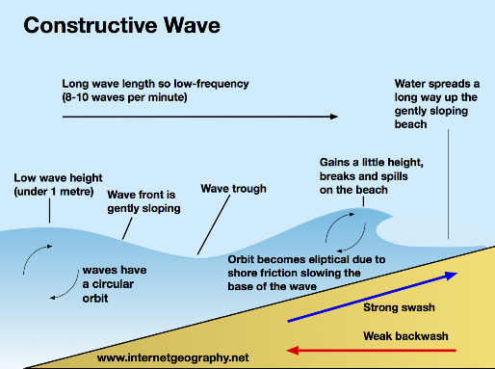

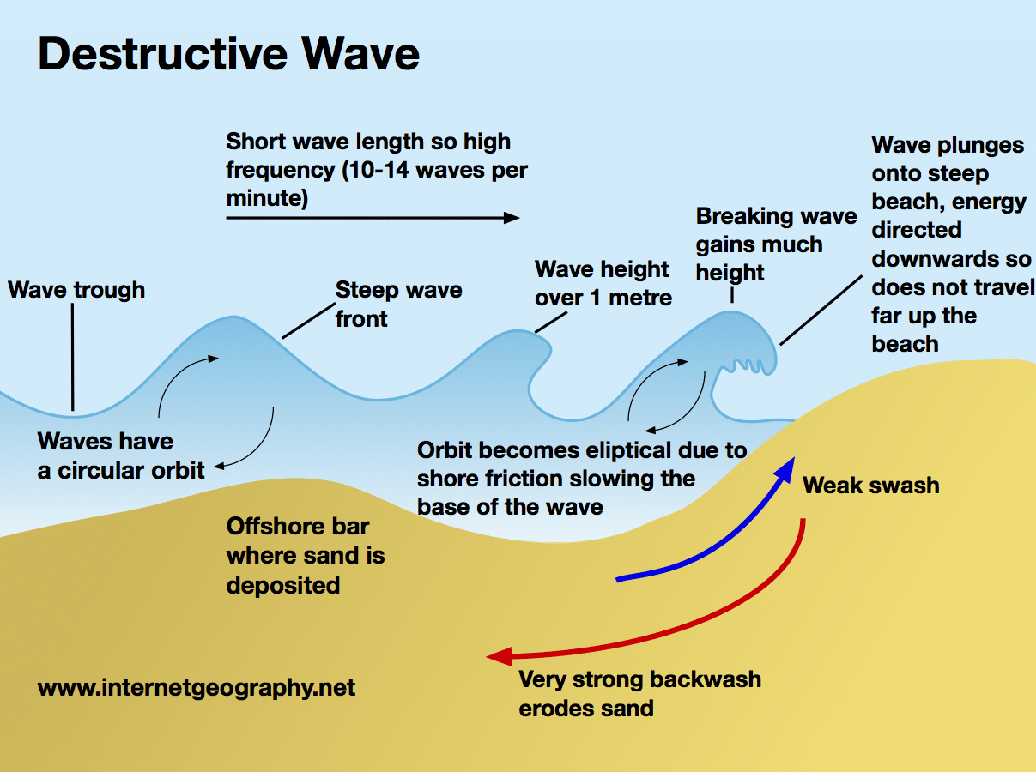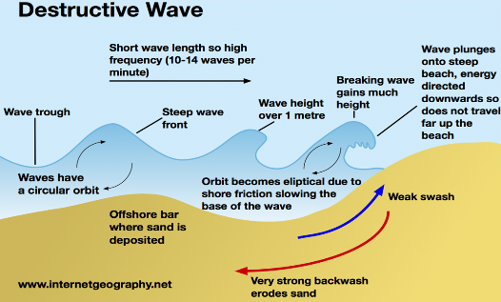

**Wave types**

|  |  |  |
| --- | --- | --- |
|  | Constructive | Destructive |
| Where is it formed? | Formed by storms often hundreds of kilometres away. | Formed by local storms close to the coast. |
| When is it common? | Summer | Winter |
| Is the swash or backwash stronger? | Stronger swash pushes sand and pebbles up the beach. | Stronger backwash erodes sand and pebbles and can destroy the beach |
| Winds and energy | Weaker winds, low energy | Stronger winds, high energy |
| Wave height | Low | High |

**Wave formation**

* Waves are formed by the wind blowing over the sea
* Friction with the surface of the water causes ripples to form
* These develop into waves

Powerful/big wave needs…

1. Long fetch (the distance the wind blows across the water)
2. Blowing for a long period of time
3. High wind speed/strength

Geography – Coastal Landscapes

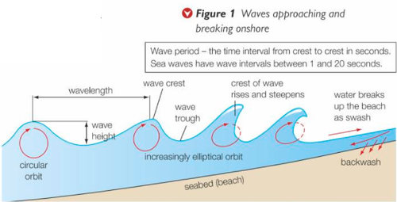

**Mass Movement**

Mass movement is the downward movement of weathered material and rock under the influence of gravity.

|  |  |  |  |  |  |
| --- | --- | --- | --- | --- | --- |
| Rockfall | Landslide | | Mudflow | | Slumping/Rotational slip |
| Involves fragments of rock breaking away from the cliff face, often due to freeze-thaw. | Waves break at foot of cliff and erode to create a wave-cut notch. Overhang is created and blocks of rock slide downhill. This usually occurs where there is more resistant cliff material. | These occur when saturated soil and weak rock flows down a slope. These typically occur where cliffs are made of boulder clay. | | Soft boulder clay holds rainwater and runoff. Waves erode base creating wave-cut notch. Weight of saturated clay causes slumping along curved surface. | |

**Waves approaching the coast**

1. Circular orbit in open water (little horizontal movement).
2. Friction with seabed distorts circular motion.
3. Increasingly elliptical orbit as water becomes shallower, and waves move forward. The crest of the wave moves faster.
4. Wave breaks and collapses onto beach. Water rushes up as **swash** and returns as **backwash**.

**Coastal Erosion**

|  |  |
| --- | --- |
| Type | Explanation |
| Hydraulic power | The power of the waves as they hit a cliff. Trapped air is forced into cracks in the rock eventually causing it to break up. |
| Abrasion | The ‘sandpapering’ effect of pebbles grinding over a rocky platform. |
| Attrition | Rock fragments carried by the sea knock against each other becoming rounded. |
| Solution | Dissolving of soluble chemicals in rock e.g. limestone. |
| Corrasion | Rock fragments picked up by the sea are thrown at the cliff. They scape and wear away the rock. |

**Coastal Deposition**

Water slows down, and waves lose energy.

* Mostly by constructive waves as swash is stronger.
* Some bays are protected by spits, waves in bays slow down, lose energy, can no longer carry sediment and deposit it.
* Waves lose energy when it is refracted around headland, headland absorbs most of the energy, waves have less energy when reaching the bays, deposition.

**Weathering**

|  |  |
| --- | --- |
|  | Example and description |
| Mechanical | Freeze-thaw:   * Water collects in cracks * At night, water freezes, expands and makes cracks bigger * Ice thaws, and water seeps deeper into crack * Repeated freeze-thaw causes fragments to break off |
| Salt weathering:   * When water evaporated from cracks, it leaves salt crystals * Crystals grow and expand in cracks * Puts pressure on rocks and flakes break off |
| Chemical | Carbonation:   * Rainwater absorbs CO2 from air, making it acidic * Contact with alkaline rocks (limestone) produces chemical reaction 🡪 rocks dissolve |
| Biological | Plant roots grow in cracks, and animals burrow into weak rock. |

**Factors that make erosion higher**

* Winds blowing for a long time

No beach to buffer the waves

* Faults/joints in the rock
* Strong winds, large fetch
* Headlands jutting out to sea
* Soft rock (clay)

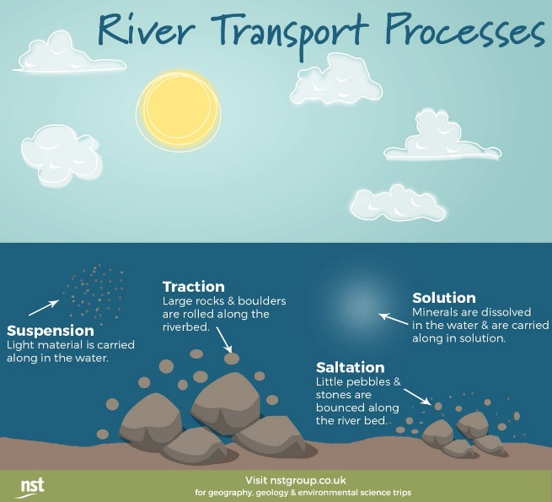

**Coastal Transportation**

**Longshore drift**: is the movement of material along the shore by wave action.

1. Waves approach the beach at an angle due to prevailing wind
2. Swash carries material up and along beach at angle
3. Backwash carries material back down beach at right angles (gravity)
4. This process moves material along the beach

**Factors that make deposition higher**

* In low energy, sheltered bays
* Small fetch, weaker wind
* Large flat beach, swash spreads over large area, weakens wave
* Duration of wind is short
* Engineered structures like groynes trap sediment
* Deposit updrift (eroding headland)
* Tidal material trapped behind a spit

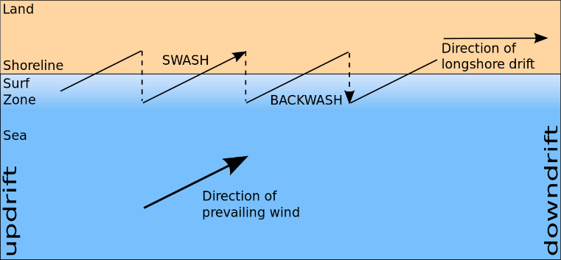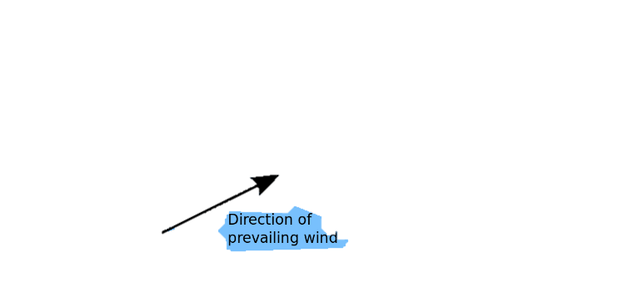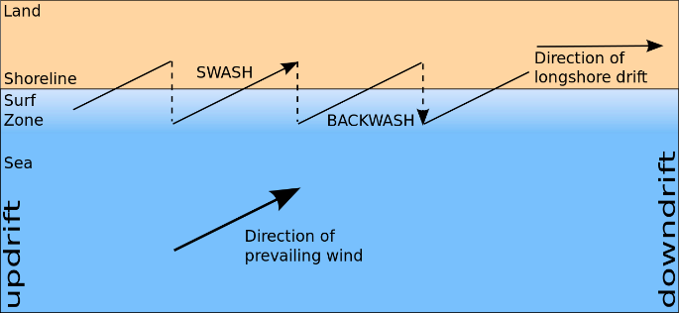

**Erosion landforms: Headlands and bays**

1. Weaker bands of rock (e.g. clay) erode more easily to form bays
2. As the bays are sheltered, deposition takes place and sandy beaches form
3. Tougher, more resistant bands of rock (e.g. limestone/sandstone) erode more slowly
4. They stick out to form headlands. Erosion dominates, so there are no beaches.

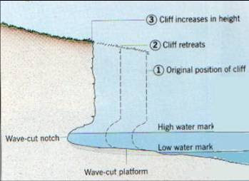

**Erosion landforms: Cliffs and Wave-cut platforms**

1. When waves break against a cliff, erosion close to the high tide line will wear away the cliff. A wave-cut notch is formed.
2. Over time, the notch gets deeper, undercutting the cliff.
3. The overlying cliff collapses. The cliff retreats over time after repetition.
4. A gently sloping rocky platform – a wave-cut platform – is formed.
5. It is smooth due to the process of abrasion (it may be scarred with rock pools).

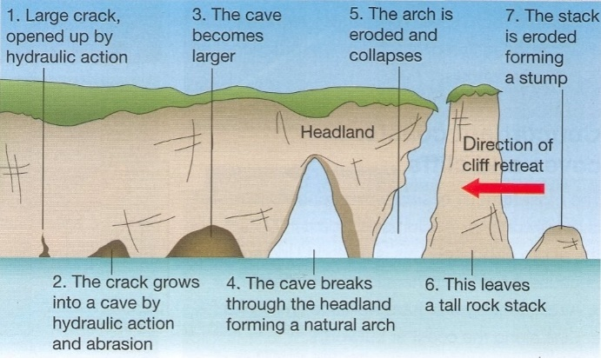

**Deposition landforms: Spits**

1. Longshore drift transports sand along the coast.
2. Where there is a sharp bend in the coastline, there is a drop in energy, so waves will deposit material and gradually build up a ridge.
3. The shape of the coastline changes and the ridge grows out into the sea over time.
4. The spit is exposed to changes in wind direction and wave direction. This causes the end of the spit to form a recurred end.
5. A saltmarsh forms in the sheltered water behind the spit because it is a low energy zone.

**Erosion landforms: Cave to stump**

1. Lines of weakness (e.g. joints or faults) in resistant rock are vulnerable to erosion.
2. Abrasion and hydraulic action widen the joint or fault forming a cave.
3. Erosion may lead to two back-to-back caves breaking through a headland to form an arch.
4. The arch is enlarged by erosion and the roof is attacked by weathering processes and eventually collapses.
5. This leaves an isolated stack.
6. The stack is eroded and collapses leaving a stump.

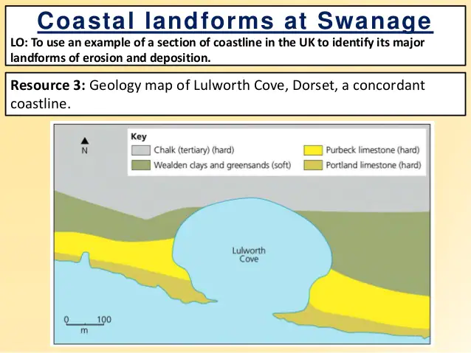

**Deposition landforms: Sand Dunes**

1. Embryo dunes form around obstacles (e.g. rocks)
2. Dunes develop and are stabilised by vegetation (e.g. marram grass) to form fore dunes and tall yellow dunes
3. Decomposing vegetation makes sand more fertile and a wider rand of plants colonise the back dunes
4. Ponds (dune slacks) can form in depressions.

**Erosion landforms: Cove**

1. There is a band of resistant rock closest to the sea and a land of less resistant rock inland (concordant coastline).
2. The waves seek out faults in the hard rock and erodes using abrasion and hydraulic action through to the soft rock.
3. Wave processes erode the softer rock faster and this leaves a circular cove with a narrow entrance where the sea enters. The waves are also refracted within the cove, spreading out to erode in all directions.

**Deposition landforms: Beaches**

* Sandy beaches are mainly found in sheltered bays and are created by constructive waves.
* Along high-energy coasts (e.g. England’s southern coast) sand is washed away leaving behind a pebble beach.

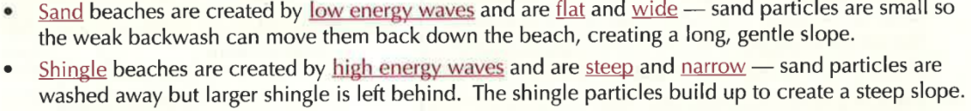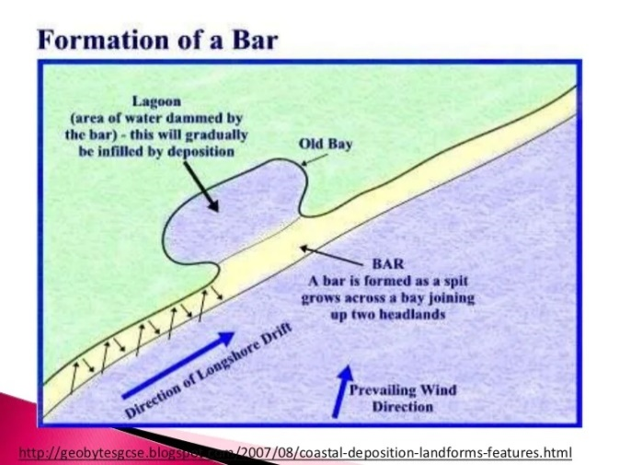

**Deposition landforms: Bars**

1. Longshore drift may cause a spit to grow right across a bay, trapping a freshwater lake behind it.
2. An offshore bar forms further out to sea. Waves approaching a gently sloping coast deposit sediment due to friction with the seabed. The build-up of sediment offshore causes waves to break at some distance from the coast.
3. In the UK, some offshore bars have been driven onshore by rising sea levels following ice melt at the end of the last glacial period. The type of feature is called a barrier beach.

|  |  |  |  |
| --- | --- | --- | --- |
| Landform | Description | Type | Example |
| Arch | A wave-eroded passage through a small headland. | Erosion | Durdle Door |
| Cove | A cove is a small type of coastal inlet that have narrow, restricted entrances, and are often circular or oval. | Erosion | Lulworth Cove |
| Wave-cut platform | A wave-cut platform is a wide, gently sloping surface found at the cliff’s base and extends into the sea. | Erosion | Kimmeridge |
| Headland/Cliff | A headland is a cliff that sticks out into the sea and is surrounded by water on three sides. | Erosion | Durlston Head |
| Stack | A stack consists of a steep, vertical column of rock in the sea near a coast. | Erosion | Old Harry |
| Bay and beach | The areas where the soft rock has eroded away, next to the headland, are called bays. | Deposition | Swanage |
| Sand dunes | Accumulations of sand that gather on a beach, often created around obstacles on the beach. | Deposition | Studland |
| Spit | A spit is an extended stretch of beach material that projects out to sea and is joined to the mainland at one end. | Deposition | Sandbanks |
| Bar | A bar is a ridge of sand or single that joins two headlands either side of a bay. | Deposition | Chesil beach |

**The Dorset Coastline**

Swanage lies on the south coast of England. The surrounding coastline has a range of coastal erosion and deposition landforms influenced by different rock types and geological structures. Rocks have been folded and tilted so that different rock types reach the coast.

**Concordant coastline** forms where rock types run parallel to the coast, so the coast is formed of one type.

**Discordant coastline** forms where there are alternating bands of harder and softer rocks, creating headlands and bays.

**Soft Engineering**

Soft engineering schemes are generally cheaper than hard engineering, though may need more maintenance. But there are more sustainable and are the preferred option for coastal management

|  |  |  |  |
| --- | --- | --- | --- |
| Method | **Beach nourishment and reprofiling** | **Dune regeneration** | **Dune fencing** |
| How it works | * Sand or shingle is dredged offshore and transported to the coast by barge. * It is dumped on the beach and shaped by bulldozers creating a wider, higher beach. * Friction makes waves lose energy and erosive power, protecting the land behind. | * Marram grass is planted to stabilise dunes and help them develop, which makes them effective buffers to the sea. * Fences keep people off newly planted areas | * Fences are constructed along the seaward side of existing dunes to encourage new dune formation * New dunes help to protect existing dunes |
| Pros and cons | * Blends in with existing beach * Bigger beach increases tourist potential * Expensive * Needs constant maintenance | * Maintains a natural environment – good for wildlife * Relatively cheap * Time consuming to plant grass and construct fencing * Can be damaged by storms | * Little impact on natural systems * Controlling access protects other ecosystems * Can be unsightly * Needs regular maintenance, especially after storms |

**Hard Engineering**

Hard engineering uses artificial structures to control natural processes.

|  |  |  |  |  |
| --- | --- | --- | --- | --- |
| Method | **Sea walls** | **Groynes** | **Rock Armour** | **Gabions** |
| How it works | * Concrete or rock barrier at the foot of cliffs or top of beach * Curved to reflect waves out to sea * Step slope absorbs wave energy * Drains allow water out to sea to return flood water | * Rock or timber structures built at right angles to beach * They trap sediment moved by longshore drift and enlarge the beach * Effective at increasing a natural barrier of beach, and can create calmer inshore water | * Piles of large boulders at foot of cliff * Gaps between rocks allow water through and disperses energy of waves and reduced their erosional power. * If made of hard rock (e.g. granite) it is eroded slowly | * Rock-filled wire cages that support a cliff and provide a buffer against the sea * Absorb wave energy * Improve drainage of cliffs |
| Pros and cons | * Effective at stopping the sea * Often creates a walkway * Can look obtrusive and unnatural * Very expensive; high maintenance costs * Erosion at base can undermine sea wall foundations | * Create a wider beach – good for tourism * Not too expensive * Interrupting longshore drift can lead to increased erosion elsewhere (problem is therefore shifted, not solved) * Require maintenance and repair * Unnatural and rock groynes are unattractive | * Relatively cheap; easy to maintain * Can add interest to the coast * Rocks are often from elsewhere and don’t fit in with local geology * Expensive to transport rock and can be obtrusive | * Can improve cliff drainage, cheap * Eventually vegetated and merges into landscape * Unattractive initially * Cages rust within 5-10 years |

**Managed Retreat – Medmerry (CASE STUDY)**

Managed retreat allows the sea to flood or erode an area of relatively low-value land.

**Location:** Selsey, West Sussex (South East England)

|  |  |  |  |
| --- | --- | --- | --- |
| Reasons for the management | | The management strategy | |
| To prevent the flooding of 348 properties, a water treatment plant and a main road. The last breach in 2008 cost £5 million. | | **Embankment**: a 2km clay bank made inland was constructed so the properties behind it are protected. | |
| **Channel:** Behind the embankment, a channel was built along its whole length to collect draining water. 4 outfall structures were built so that the water coming in can fill the channels without flooding the area, protecting properties and farmland. | |
| The old seawall was damaged, and was too expensive to replace. | | **Rock Armour:** Placed on the seaward edges of the embankment. This used 60,000 tonnes of hard rock from Norway. This means that as the waves come to the coast they lose their energy and erosive power, protecting the residential area of the coast from being flooded. | |
| The land was low-value non-residential flat farmland. | | **Breach:** Once the embankment and rock armour were in place, a 110-metre breach was made in the shingle band, creating a new intertidal area. This means that the land absorbs the power of the waves, reducing the risk of flooding. | |
|  | Positives | | Negatives |
| Social | * 1 in 1000 chance of flooding * 10km of footpaths and 7km of new bike paths | | * Some residents feel that EA should have looked into other options * Some resented such an expenditure in such a sparsely populated area |
| Economic | * Tourism expected to increase with 2 new car parks and 4 viewing points * Flooded area expected to become important fishing nursery, boosting fishing industry | | * High cost of £28 million * 3 farms growing oilseed rape and winter wheat had to be abandoned |
| Environmental | * Water voles, crested newts and badgers protected * 300 hectares of new intertidal habitats forming e.g. ducks and lapwings | | * Despite planning, habitats of existing species such as badgers would have been disturbed |