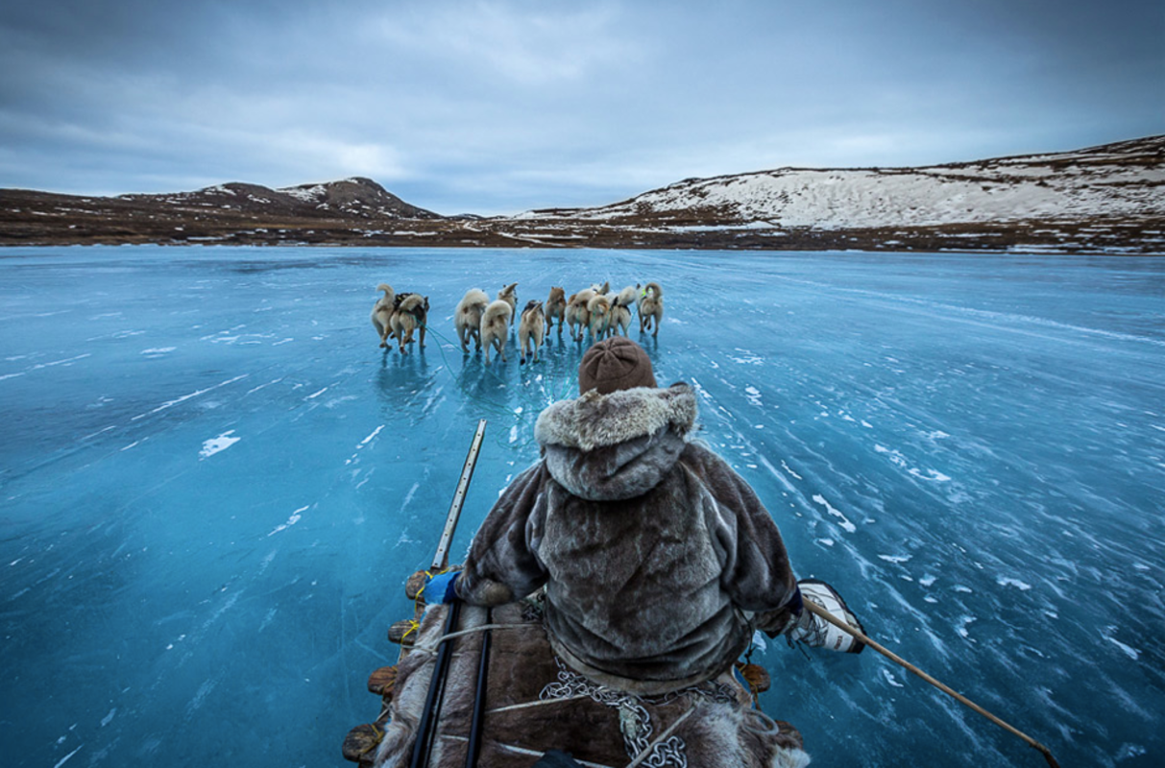

The crunching sound of compressing snow underneath the wooden foot of a sleigh echoed through the land, ricocheting off of every standing tree before it disappeared into the mist. It glided across the blanket like a raindrop racing down a windowpane, yet it dodged the endless array of trees with sharp turns here and there. The wolves, only a few meters ahead, pounded their powerful hind legs – determined to pull against the lead attached to them. Their thick, pristine white fur that coated them withstood the pinches of bitter coldness as they strived for a way out of the forest. Mountains in the distance, dressed in a rocky-black suit with a sheer white top hat, watched the pack as it appeared out of the bush of branches and led the sleigh towards safety. The man crouching on top screamed at the top of his lungs:

‘FASTER, FASTER!’ His goal was to escape, to escape the horror that ran after him.

On every stomp to the ground, the ogre shook the land like a furious, raging earthquake. Thousands of trees, the size of toothpicks in comparison to his foot, plummeted to the ground. His ice-blue eyes placed on his paper-screwed face located his dinner. Enormous icicles attached to his every limb shattered and stabbed into the innocent, crying ground when his foot reached it. The sound of his deafening growling stomach ruled over all other miniscule sounds, while he longed for human flesh.

As the mist cleared the wolves’ path, the man’s ranging, pounding heart ceased to throb. There, right in front of his eyes was the thing that would save his life: the frozen lake shimmered in his hopeful eyes. He held on tight to the racing sleigh and hoped for the best as he quickly snapped his head back to see the monster. Bu-bum, bu-bum, bu-bum… While the ogre accelerated towards him, his heart restlessly started pumped blood yet again. His whole body seared with the heat as the icy wind smacked his scarlet cheeks.

He was nearly at the lake. So close.

The ice, just inches away from his sleigh, welcomed it on to its slippery surface and his sleigh scooted across it in a flash. He had been saved. Greed was painted across the ogre’s towering figure: his bitter eyes were fixed onto the prey; his mind dug up memories of its crunchy, yet smooth texture; and his drooling mouth was ready for the taste of innocent flesh. Not noticing the catastrophe that lay ahead, he cascaded down onto the frozen floor after his foot touched the icy cover of the lake. The meter-thick ice below opened a gate to hell with an enormous explosion and ice shards flung from their place into the crisp air before they began their descent back to their place. When they zoomed back down, their sharp body shattered into millions of jigsaw pieces and scattered across the ice. The water beneath broke through at its chance of freedom as the ogre sunk into the depths of the dark lake. His final enraged glance at the man was the last image that filled his mind before he was gladly engulfed. Ice-sharp water replaced the air in his pleading lungs, which made its way to the surface in the form of bubbles.

As the man raced away, his face slowly recovered from shock, shoulders slumped back down, and his clenching jaw unclenched. He breathed. While his mind replayed the encounter that almost killed him, he drew his huge, furred coat together and stared calmly at the surroundings, exhausted by his own fear.