Look in detail at this extract, from **lines 9 to 15** of the [source](https://extranet.aqa.org.uk/):  
  
How does the writer use language here to convey Mr Fisher’s views on books and stories of the past?  
You could include the writer’s choice of*:*

Mr Fisher remembered a time – surely, not so long ago – when books were golden, when imaginations soared, when the world was filled with stories which ran like gazelles and pounced like tigers and exploded like rockets, illuminating minds and hearts. He had seen it happen; had seen whole classes swept away in the fever. In those days, there were heroes; there were dragons and dinosaurs; there were space adventurers and soldiers of fortune and giant apes. In those days, thought Mr Fisher, we dreamed in colour, though films were in black and white, and good always triumphed in the end.

* words and phrases
* language features and techniques
* sentence forms.

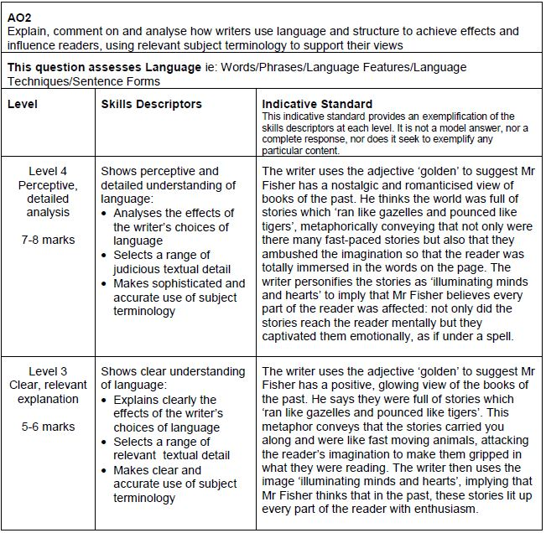**[8 marks]**

**Response 1**

In this extract Joanne Harris evokes the fact that Mr Fisher likes the stories in the past better than the ones in the present. This can be shown by the phrase “When books were golden,”. This shows that Mr Fisher feels that the books in the past had more imagination and thrills involved. Whereas the books in the present don’t have much adventure or mystery they are just bland and unexciting.

**[2 MARKS]**

**Response 2**

In the extract the writer uses metaphors to convey Mr Fishers views on books and stories of the past. This is seen in the quote ‘illuminating mind and hearts’ the word ‘illuminating’ suggest a glow in the child and shows Mr Fisher like to see when children are learning and succeeding. This word also is imagery as you can picture in your mind the happiness and glow from the child.

Another way the writer uses language to convey Mr Fishers view on Books and Stories of the past is similes, this is seen in the quote ‘ran like gazelles and pounced like tigers’. this is interesting because it conveys Mr Fishers excitement with the constant repetition of similes.

**[3 MARKS]**

**Response 3**

In this part of the extract the writer uses different language techniques to show how Mr fisher feels about how books have changed.

At the start of the extract, he says ‘surely, not so long ago – when books were golden’ the word ‘golden’ shows that he thought the books were great and maybe they were worth a thousand words and where lucky to have like you are lucky to have gold. It shows that he used to be very grateful to have the books he had.

The writer also uses language to convey Mr Fishers views on old books and stories by using similes. ‘When the world was filled with stories which ran like gazelles’. In my opinion I think that this means the stories flowed out and that there was always knew stories very fast because gazelles can run very fast but very elegant, so they come out fast but are always of good quality. ‘Exploded like rockets’ is another simile that is used in the same sentence. When rockets explode it is big, gets everyone’s attention and everyone knows about it like everyone knew about the old books when they were released.

The writer also uses semi colons to convey Mr Fishers views on stories of the past. ‘In those days, there were heroes; there were dragons and dinosaurs; there were space adventures and soldiers of fortune and giant apes.’ The use of semi colons shows that there is a big list of things for him to say, he can go on about all the amazing things the old books and stories had in them.

In this extract the writer shows that he misses the old books and stories and wishes that all books and stories were still like that.

**[4 MARKS]**

**Response 4**

The writer uses a variety of positive imagery to convey Mr Fisher’s views on books and stories of the past. The writer uses similes to show the rush of happiness that fills Mr Fisher as he describes the stories as ‘running like gazelles! ‘Gazelles’ have connotations of child-like, fun, images, which shows that Mr Fisher is excited by them. Also, the simile used in ‘pounced like tigers’ shows that once the stories used to have meaning. They used to have dramatic effect on the reader as ‘pounced’ could imply that the stories engaged the reader so much that they didn’t want to put the book down. Therefore, this shows that Mr Fisher’s views on books and stories have changed as in the past he believed that they were very engaging.

Mr Fisher personifies books of the past, which is that effective as it shows that they once had meaning. The fact that Mr Fisher says, ‘books were golden’, shows that they were valuable and precious. Books from the past may have had a huge effect on Mr Fisher hence why he remembers them and cherishes them. He is unable to forget the stories within them as they were so fantastic that they engraved themselves so they cannot be forgotten.

The writer uses long complex sentences, with lists to show how long lasting the memories of the books and stories are. The list to describe what stories consisted of shows how effective the stories were that Mr Fisher still remembers them. The long sentences also show a sense of longing that Mr Fisher feels to read stories like they were in the past.

**[5 MARKS]**

**Response 5**

The writer uses metaphors to convey Mr Fisher’s views on books and stories of the pasts. Mr Fisher believed in the past ‘books were golden’ and it was a time when ‘imaginations soared’. The use of metaphors suggests that Mr fisher loved the books and stories of the past and believed that they contained something unique and special, that real life couldn’t compare to it. Mr Fisher had also seen ‘whole classes swept away in the fever’, this emphasises the magic Mr Fisher cherished in books of the past and that they were powerful enough to capture everyone’s attention. Also, the use of positive imagery through the use of the adjective ‘golden’ and the verb ‘soared’ suggest to the reader that Mr Fisher perceived books from the past in a more positive light than those in the present.

The writer also uses a simile to convey Mr Fisher’s reaction to books of the past. Mr Fisher describes stories that ‘ran like gazelles and…’. The use of this animalistic imagery within this simile, suggests Mr Fisher believed books in the past were more thrilling and exciting, this also supported by the verbs ‘ran’, ‘pounced’ and ‘exploded’ which gives connotations of energy and fast-paced action to the reader. Overall, the reader can see Mr Fisher views books in the past being more entertaining and appealing.

**[6 MARKS]**

**Response 6**

One way the writer presents Mr Fisher’s viewpoint is through the use of powerful imagery. The writer states that Mr Fisher remembers a time “when books were golden” and when they “illuminated minds and hearts”. This strong and consistent imagery brings to mind the motif of light. To say that the books were “golden” creates an idea that they were highly precious – as gold is – something to be treasured and looked upon with care. Indeed, the idea that these books were “illuminating minds and hearts” not only reinforces the notion that they were special, but it also gives reason to it. The verb “illuminating” conjures up a clear image of light resonating to and through everything in its path; and the idea that these books illuminated “minds and hearts” helps to put across the idea that books were ‘enlightening’. These ‘golden’ books brought a new sense of clarity to people, that they made the readers feel and think in a different way; and this is why Mr Fisher regards them as ‘golden’.

Another way the writer expresses Mr Fisher’s viewpoint is through the use of highly romantic language. Mr Fisher’s thoughts seem to romanticise old books a great deal. For example, the constant reference to “in those days” allows the reader to glean that “those days” are perceived by Mr Fisher as better literary times, and so he wishes to return there. This is a common theme to which most people can relate; the ideal of wishing to return to ‘those days’. What’s more, the phrase ‘we dreamed in colour, though films were in black and white’ romanticises the old books even further. It contrasts the ‘black and white’ films with the ‘colour’ of the books; inferring that the old books made for a vibrant life, that they were the escapism from the ‘black and white’ of everything else. Consequently, Mr Fisher now wants to return to the ‘colourful’ times – as it was a time when he was most happy.

**[8 MARKS]**

**Response 7**

The writer uses words such as ‘golden’ and ‘illuminating’ to convey Mr Fishers views on books and stories of the past which connote a sense brightness and happiness. This makes the reader associate their own subjective feelings of brightness and happiness with Mr Fishers views; Creating a more vivid image of happiness to associate with Mr Fishers character.

The writer uses similes such as ‘ran like gazelles’ which elicits an inference of freedom through the graceful associations of a gazelle. This allows the reader to interpret the sense of fluidity that Mr Fisher feels when thinking of books and stories of the past creating a nostalgic atmosphere. The writer uses a long complex sentence form with repeated use of the comma to mimic Mr Fishers train of thought ’books were golden… imaginations soared, … exploded like rockets, …’.  This increases the pace of the text and informs the reader on the sense of freedom and joy that Mr Fisher associates with books and stories of the past.

This is also achieved through the use of metaphors such as ‘whole classes swept away in the fever’. By referring to this sense of freedom children felt as a fever which has connotations of something burning, the reader interprets this as the burning passion that past generations once felt for books and how Mr Fisher is sad to see their passion fade – ‘Surely – not long ago’.

**[7 MARKS]**