You now need to think about the **whole** of the [source](https://extranet.aqa.org.uk/).  
  
This text is from the beginning of a short story.  
  
How has the writer structured the text to interest you as a reader?  
  
You could write about:

* what the writer focuses your attention on at the beginning of the source
* how and why the writer changes this focus as the source develops
* any other structural features that interest you.

**[8 marks]**

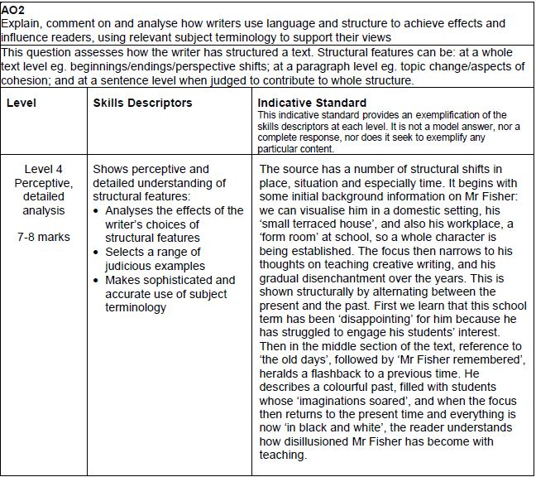

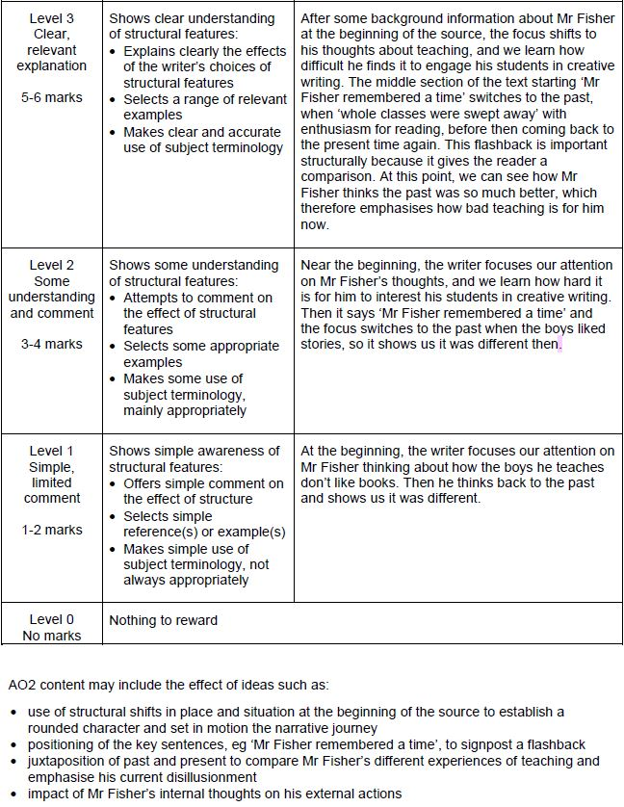

**Response 1**

The writer focuses your attention on at the beginning of the source on his past, so the reader has a clear understanding of the past of the story the character is based on. The writer changes his focus as the source develops to show the character could change as the story timeline develops because his actions within the story could cause the structure of the story to change.

The writer uses different types of structural features to interest the reader to carry on reading because the writer knows what part of the story timeline that people are interested in.

**[1 MARKS]**

**Response 2**

The writer has structured the text to interest me by, focusing the start of the extract on Mr Fisher and his everyday life, which lead me to believe the extract would be about why he lives along and what has happened within his life, although this is just a brief opening to have people settle into the extract and to show he has a life on the outside of teaching, but, paragraph two completely switches and begins opening up about his life and about his job, it then becomes about the class he teaches.

In paragraph 7 a short sentence is used “He began to sweat” the structure of this is that its snappy and happened quickly.

Although the extract does not have a semantic filed, other than the first paragraph every other sentence is about the school so it has that feel.

**[3 MARKS]**

**Response 3**

The writer structures the text to interest you as a reader by beginning the text focused on Mr Fisher in a small form room. This interests the reader as it begins with small pieces of information about Mr Fisher, such as he ‘lived alone’ and ‘in the form room after school’. This makes the reader question what Mr Fisher is doing and want to know more about him.

As the story develops the focus widens to Mr Fisher views on people and books. It also shifts to past and present students. In paragraph 3 and 4 we can see the opinion and view of books change from ‘golden’ and ‘dreamed in colour’ to ‘was in black and white’ and ‘everything was boring’. It changes from a positive, exciting opinion to a dull, boring view.

This gives the reader contrast and variety to the source which may make them question why, but also provoke them to want a happy ending, urging them to read on.

Towards the end of the source the viewpoint and focus is widened even more to introducing a new character ‘Alistair Tibbit’. The phrase ‘there was a spark in him’ interests the reader to find out why and as the source develops it describes the boy as exciting and his story as ‘entirely original’.

The description of Mr Fishers reaction also shows the excitement and mystery of the story which the readers would be intrigued to know why.

**[5 MARKS]**

**Response 4**

At the beginning of the source the writer uses description to enable the reader to understand the protagonist of the story but also to help the reader follow his life as if it was normality instead of a story. After first describing Mr Fisher’s seemingly normal life, the writer uses sharp contrast to then show Mr Fisher’s life in the past and how books that were once ‘golden’ have changed dramatically. This was consciously done to capture the reader’s attention and lead to intrigue as to why books have changed so much, making the reader want to read on. the writer then switches the story back to the present but writes with slightly more negative imagery and phrases such as the analogies to how ‘everything was in black and white’ suggesting the dullness of life now as well as describing Mr Fisher’s ‘gloomy train of thought’, inferring as much boredom from him as his students now receive from reading.

Later in the story, the writer contrasts once again by this time using sensory detail to show the effect that Tibbet’s story has had on Mr Fisher and overall leaves the short story on a metaphorical cliff hanger because reader’s want to know what Tibbet’s story involved and how it was ‘entirely original’ and caused Mr Fisher to ‘smile’.

**[6 MARKS]**

**Response 5**

At the opening of the extract, the writer focuses on Mr Fisher, describing him as a seemingly boring English teacher. The reader is intrigued as to what lies behind this teacher and what role he plays in the story. The writer then zooms out to describe his despair with his class. Again, this seems bland and usual, and the reader is interested as to what will happen.

The writer then ‘zooms in’ on Mr Fisher again, showing his rich memories of books in the past, and contrasting those memories with the dullness and “disillusionment” he feels when teaching his superficial class. This causes the reader to wonder if there will be a change, and what it will be.

The writer the ‘zooms in’ even more to focus on one particular student’s work, Alistair Tibbet, revealing that he does have “imagination”. The reader realises that this is the turning point and is compelled to continue reading to find out what the change will be. She then slowly describes Mr Fishers “strange sensations” when reading Tibbet’s work, showing the excitement and hope which fills him –and vaguely and ambiguously describing the uniqueness of Tibbets work, although the reader does not yet know. The reader will connect this to the description of Mr Fisher’s memories earlier on. This draws in the reader who will want to find out what is so spectacular about this boy’s work.

The writer starts of with a boring and regular teacher marking his work, but then hints at what is to come by describing the teachers vivid, “colourful” memories. She uses foreshadowing to hint how this boy, Tibbet, who has been singled out from the class, is different from the rest and his work is different and unique. This interests the reader and compels him/her to read on.

**[7 MARKS]**

**Response 6**

As the extract is from the exposition of the short story, there is expected to be a way to go before any rising action. This is why the beginning of the text we are simply introduced to Mr Fisher and his thoughts. However, by focussing on the disappointment in Fisher’s life and through the use of a flashback to depict how it once was in the ‘good old days’ the writer seemingly foreshadows that perhaps Mr Fisher will once again read a story that brings the energy he remembered back to him. At the pivotal line ‘good always triumphed in the end’ the writer allows the reader to question whether she is foreshadowing an end that Mr Fisher wants, for her own story, his story, or whether we, like Fisher, will also be disappointed. With two contrasting end focus sentences, the first on line 23 of ‘the magic had run out’ and then the final line of ‘something entirely original’, the writer juxtaposes the disappointment that Fisher once had and brings back this ‘hope’ that the reader so wanted for him and confirms that good really does triumph in the end.

At the zooming in on the ‘tightening’ of Fisher’s diaphragm, and his senses in response to the story, Harris shifts the focus for us from a scene of nostalgic depression to a more hopeful and perhaps inspiring point for both Fisher and thus the reader.

**[8 MARKS]**

**Response 7**

The writer starts with a description of the life of ‘Mr Fisher’. This helps the reader to understand the character well before he is put into a scene. They get to understand what kind of a person Mr Fisher is. This helps to avoid any confusion for the reader as they can develop their knowledge on a character before the story has started. Perhaps the writer does this because Mr Fisher is going to be a key character of the story so the reader needs a clear understanding of him in order to gain interest.

Next the writer shifts the focus onto the school. Here she describes the disappointment of the students creative writing results. This helps the reader to keep engaged with the story as their focus is now on something new, the school. They have already learnt about Mr Fisher so they are keen to know about the kind of school he works in ‘St Oswald’s’. The reader creates an understanding of the ‘boys in class 3F’ making it even more dramatic when one boy’s story gives great hope to Mr Fisher. Perhaps the writer does this to interest the reader more as they see the drastic change in ‘Alistair Tibbet’s’ writing later on in the play.

Finally, the writer leaves the reader on a cliff hanger at the end of the source interesting the reader as it creates a sense of mystery as they are curious to know what the story is about. The story is described as ‘something new. Something entirely original’. The use of the short sentences here at the cliff hanger helps to build up speed and excitement for the reader making them enthusiastic to find out what happens next.

**[5 MARKS]**