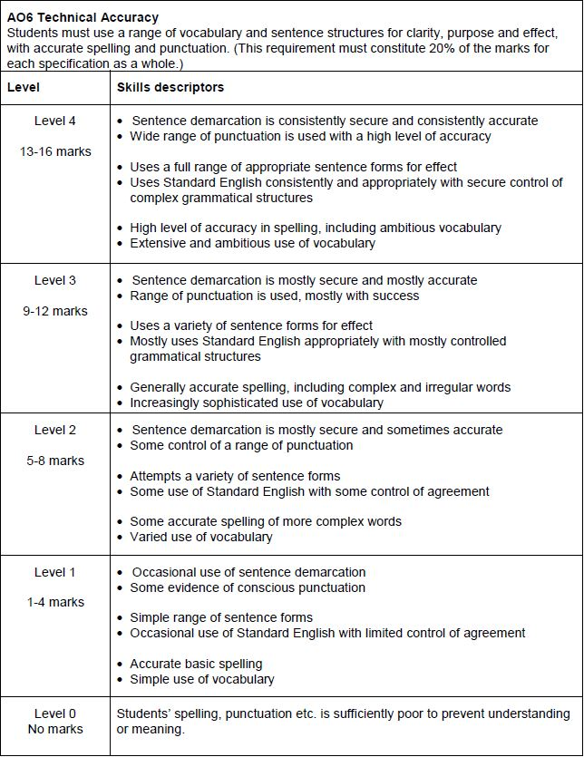A magazine has asked for contributions for their creative writing section.  
  
**Either**  
Write a description of an old person as suggested by this picture:  
  
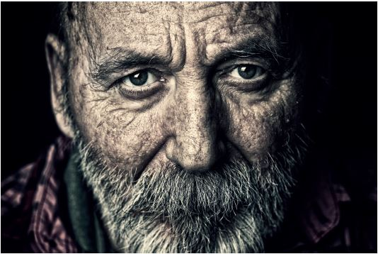  
  
**or**  
Write a story about a time when things turned out unexpectedly.

(24 marks for content and organisation

16 marks for technical accuracy)

**[40 marks]**

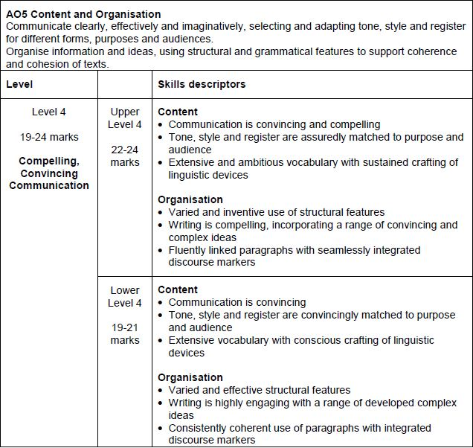

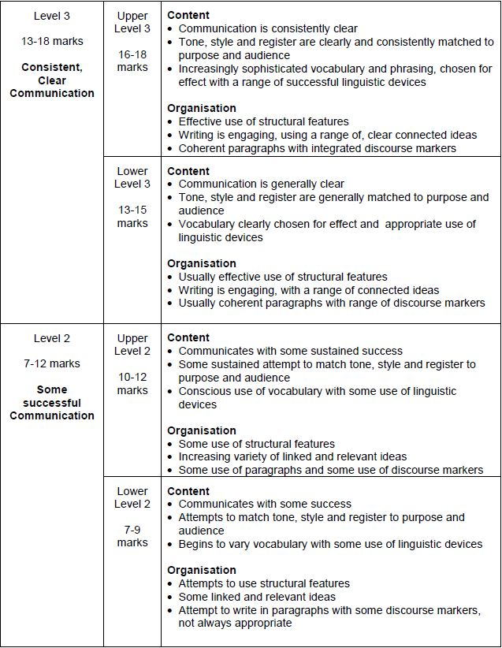

**Response 1**

The picture shows old people to look damaged and freaky in my opinion from the picture the man looks sccared mentally. I would say he looks a level of intimidating mixed with creepy. I think the image is supposed to show them as very old and that time has took its toll on them. The long beard, grey hair and damaged skin, wrinkles.

**[5,6 MARKS]**

**Response 2**

I could see it in his eye, all the pain, the love and suffering, yet hope. He gently stared at me and I began to feel my sorrow lifted as though we were sharing our thoughts then a light tear dropped to the ground then another. Each tear with so much aggony and meaning and then he smiled at me and every muscle in his cheeks reflected his joy towards me, the overwhelming joy that one has a verry few times in ones lifetime, the joy that has meaning and one remembers for the rest of their life and the joy that all the currencies in the world couldn’t pay for. Even writing couldn’t do this moment justice because a verry few amount of people would ever experience this.

**[9,6 MARKS]**

**Response 3**

The Old Man

There stood an old man surrounded by a shroud of darkness almost an endless oblivion of emptyness. His shadow like figure stood out the most as it seemed to be the only light within the room.

I could make out his face from where I was, he had long silky grey hair with blue eyes that stood out enormously, his ears were the shape of that of a goblins ear, he had lips that were cherry red, he had little divots in his lips lined with white dry skin along the rim.

He stool stationary in solotude and peace a slight lean, perhaps a back problem of some sort. My eyes were fixed on his figure, it looked as if he had no skin or fat on his body.

His clothes drowned him as if he was too small to be in them, his pants, rolled up at the waist, were rigid and wrinkled at the bottoms, and had multiple enormous tares down eaither side.

His skin on his hand was wrinkled like a Syamese cats skin, and his bone could be seen pearcing through his skin like a hot knife through butter. His cheek bones were rigid an uneven like the side of a cliff, his skin overlapped and looked almost like leather.

He wore a jacket. A denim jacket to be exact sea blue with luxorrous golden buttons to seal it, his collar stood on end like a soldier saluting his country and in the elbow, there was visible padding with the logo of the brand, the logo was purple black and pink with an italics font, ,it stood out massivly.

The old man wore brown sandles with a with a deep dark blue strap that rose up like a wave then reconeted like the break of a wave, his heal was visible and had dry flakey skin that was pealing off the back of his foot.

He had a mustache too, very well trimed a sort of greyish colour with a few black hairs that stood out like a giant in a crowd of normal sized people.

The man, when he walked had a limp, it was a suttle limp but it was there. I believe it was from age, or his frail old muscles finally starting to give way from his prosporous and mysterious life of solitude and lonleyness.

The old man left without saying a word, he majestically strolled out of the door and disapeared into the abyiss of darkness never to be seen or heard from again, at least for now.

**[11,7 MARKS]**

**Response 4**

I stood inside the entrance of the hospital doors. My dad was clutching my mum’s hand in comfort as he knew she was worried. We all were. My mum wasn’t eating properly and none of us had slept in days. I'd be broken if anything happened. I knew that. But I felt like that was all I knew.

We walked down the all too familiar corridors towards my grandmothers room. The route we took must have been walked by us a thousand times. The doctors and nurses knew us by name. As I turned the final turn before our destination I saw my mum take a deep breath.

The door creaked open and I was the first to enter. My grandmothers frail body resting in her bed. It looked uncomfortable. I didn’t know what to say to her. I wished I'd spent more time with her because seeing her in the weak, fragile state was hard. When the doctor asked to talk to us outside we followed her obediently; she looked at all of our worried faces before she smiled. She informed us that my grandmother was going to get better; she told us my grandmother would live. It was a miracle. It was unexpected, it was new I had hoped but never believed I would hear.

I ran back into my grandmothers room and embraced her. I had forgotton how that felt. I neatly folded her clothes and promised her I'd be back the next day to pack the rest of her things and take her home. She smiled and her eyes filled with warmth. That was the first time I had seen her smile since she’d been in hospital. That was the first time in three years.

I stood inside the entrance of the hospital doors. We were all excited. We were all beaming. We walked down the all too familiar corridors towards my grandmothers room for the last time.

**[14,10 MARKS]**

**Response 5**

Tom was a bright boy – gifted with intelligence, however, he was also very lazy and sedentary and inconsistent and complacent. His parent’s had faith in Tom as if it were a religion, Tom didn’t ask them to do this, Tom didn’t want them to do this. They presumed Tom, as teachers, classmates and other relatives did, that he was going to cruise through his exams. Though, Tom himself, he knew, he knew he hadn’t done enough.

Four weeks flew by like a falcon at top speed – exams done!

Tom had an extended holiday, along with everyone else his age. He expected the pressure of GCSEs to slowly float off him… they pressed harder and harder. Each and every upcoming day out for him was no longer a reason to be cheery. Instead, it was a reason to become more and more frightened. Yes, yes some days the pressure of GCSEs temporarily lifted but they'd just come back down ten times harder.

He remembers a time when the worries of school life were getting his homework diary signed:

‘Mum! Mum! Please can you sign my diary quick please?”

Or getting the correct food ingredients:

“Miss said that I need self-raising flour, icing sugar, 3 eggs and milk”

Although these were worries for Tom, looking back, they were pleasant worries. He sometimes wonders if, when 80 years old and looking back, if GCSEs will be a pleasant worry… he hopes so anyway.

This is it, one night before and Tom is more worried than ever but an uninvited excitement is also creeping up on him. He wants there to be a fast forward button .. for life. He wants to fast forward 12 hours.

Trembling, he opens the results. The huge envelope is overwhelming.

**[18,13 MARKS]**

**Response 8**

Sprinkles of snowflakes fell down in front of her, covering the weathered stones beneath her feet. Only the moonlight illuminated her surroundings, glimmering between the tangled branches of the naked forest behind her. She shivered. Nearly there, she thought to herself as she clung to the tattered cloak around her shoulders. The path forked ahead, with the right path leading directly through a village.

As she approached she peered into a market; the smell of freshly baked bread still lingered. The cry of a distant crow pierced through the air as an icy chill rushed to greet her. She traced her fingers along the fresh coat of snow that covered a wooden surface. I’ll be safe her, she thought.

Behind her the suns rays were beginning to arise, breaking through the frosted wind and clinging to everything it could touch. She closed her eyes and let out a deep breath.

Suddenly, a burst of light. A high pitched screech shot through her head and the growl of an angry hound lingered.

She froze, knowing there was no where left to hide.

They had found her.

**[19,14 MARKS]**

**Response 6**

Frail. Weak. Helpless.

The soft shell of what was once a man sits peacefully; sunken into worn cushions shrouded in a thick knitted blanket. His wife made it. Before she died. Plumes of grey – white hair lace the edges of his mouth, and wrinkles – just remains of smiles, laughs and cigarettes. They crawled, like ivy, amongst his face; encapturing it as if to restrain the memories that he clung onto.

It appeared he had not washed in a while, as the white cast of his translucent skin had grown dull. There was something about his eyes, however – streams of blue contrasted with the stark white. Like glass, it was easy to see that this man had not always been so vulnerable.

Tick. Tock.

The rhythm of the clock was often the only thing to be heard within his small bungalow – apart from the permeating cough caused by his habitual smoking. Years of doing so had yellowed his teeth and finger nails, blackened about his eyes. The man sits, stares, sputters. Who knew a few casual cigarettes with friends could do such harm. He sits, lucid transparent tubing running from his arm to the bag which was set up on the shelf.

Cancer.

It had riddled his body, stripping him of his dignity, leaving him frail, weak and helpless.

**[21,14 MARKS]**

**Response 7**

Frozen, I stare at his aged face. Ice-cold grey eyes concealing a once – warm soul that has petrified along with his spirit. Empty. Shallow. Powerless. These are the words for those eyes; the eyes that cut the air surrounding them with their unpleasant prejudice.

The eyes may be one thing, but they are partially masked by an overgrown jungle of silver and white. The branches of this forest extending across his whole face and neck, going down; reaching under his clothes and, like a weed, are found to be untamable because of the extent of their spreading existence.

Fine lines frame all these features, great ridges becoming more prominant with age.

Is there still hope hidden away? The only optimism found is the ghost of what it once was. Time as the enemy that scorched it from the battlefield with no remorse, no pity, all powerful.

Is there anything to be done?

I ask myself every moment. But that once expressive and spirited man now appears trogloditic to those expressions in comparison.

I see depths of despair emmanating from his aura of darkness. It's so dark he has almost hidden himself inside it; out of shame.

Was he ever loved?

No onlooker would ever dare assume so, because they know under this cold exterior is an even darker, scarier voice that pricks like thorns to all that dare entice it out.

There was once a time that the skin was taut and the forest, well tamed. He could have been and done anything he wanted, but as all great men do, he loved, he lost, and now …

The coldness inside him was always there, just concealed with the joy of youth and the abundance of charm he forged so well before. All gone now.

I stand here watching this man, time ticking, aging on and on. I could worry about where he will go next, but I fear that is as useless as teaching a fish to walk. I only wish there was more I could have done.

There's guilt now, so much guilt. It overcomes me in waves each more brutal than the last.

“I tried to help, I tried!”

I explain to myself, clutching at my beating heart.

“I told him time and time again, I swear!”

But it comes to no fruition. The battle has been lost, the forest grown over the battlefield, the eyes turned to ice.

I close my eyes to see the young man that once stood so tall, so proud. However when I open them again to let relality back in, somehow, like the cruel hands of fate; it is only my reflection that remains. All alone.

Where did the time go?

**[24,15 MARKS]**