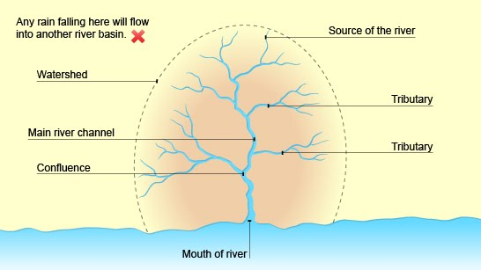

**River Transportation**

|  |  |  |  |
| --- | --- | --- | --- |
| Traction | Saltation | Suspension | Solution |
| Large boulders and rocks are rolled along the riverbed. Load carried in this way is called bedload. | Small pebbles and stones are bounced along the riverbed. The load is alternately lifted and then dropped in line with a local rise and fall in the velocity of the water. | Fine, light material (such as alluvium) is held up and carried within the river’s flow. This is called **suspended load**. | Minerals are dissolved in the water. This is a chemical change affecting rocks such as limestone and chalk. This is called **solute load**. |

**Changes in rivers and their valleys**

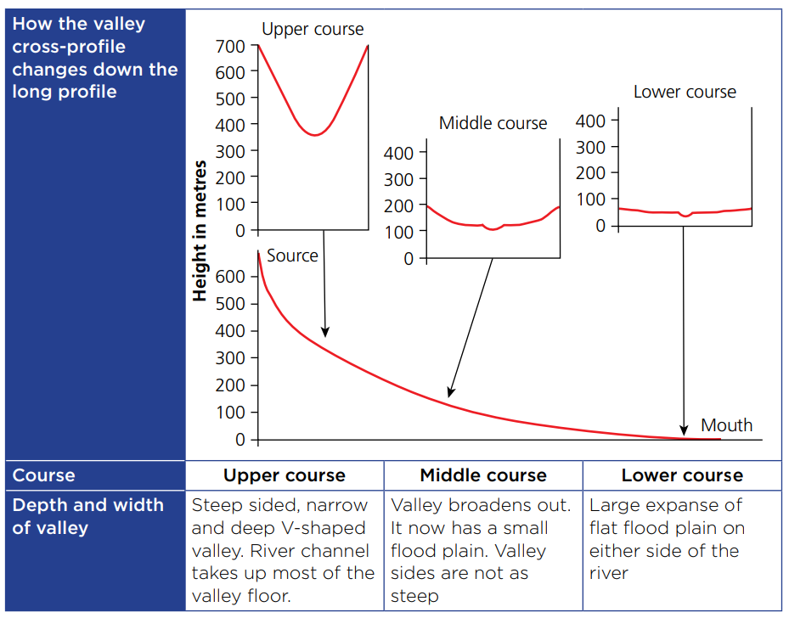

|  |  |  |  |
| --- | --- | --- | --- |
| Course | Upper course | Middle course | Lower course |
| Why does it change? | Vertical erosion by the river is the dominant process forming the V-shaped valley that is narrow and steep sided. | The gradient is less steep, so the river begins to meander and erode laterally into the valley sides causing gentle slopes. | The river is passing through low-lying country. Deposition from floods builds up the flood plain, and meanders migrate. This builds up and wides the valley. |
| Landforms and features | Waterfalls, gorges, interlocking spurs, V-shaped river, rivulets | Meanders, ox-bow lakes, Flood plains, river terraces | Flood plains, Levees, estuaries, mud flats, deltas |
| Characteristics | Soggy moorland, fast-flowing water with high carrying capacity | Very fast flow around meanders, much flatter than upper course | Very wide so flooding is big risk, deeper, brackish water, |

Geography – River Landscapes

**Drainage Basin**

**Drainage basin** is an area of land drained by a river and its tributaries.

**Watershed:** The edge of a drainage basin

**River Channel:** the main river

**Tributaries:** small rivers that join the main river

**Confluence:** the point where two rivers meet

**Source and Mouth:** the start and end of river

**River Deposition**

Deposition occurs when the velocity of a river decreases.

* Larger rocks are deposited in the upper course. They are only transported short distances during high velocity.
* Finer sediment is carried further downstream and is deposited on the riverbed or banks where **velocity is slowed by friction**.
* A large amount of deposition occurs at river mouth where gentle gradient reduces velocity.

**River Erosion – During high discharge (heavy rainfall during a storm) the river has the most power to erode.**

**Vertical erosion:** the downwards erosion into the valley floor. This is dominant in the upper course because there is a steep gradient.

**Lateral erosion:** the sideways erosion into the valley sides. This is more dominant in the Middle and Lower course of a river.

|  |  |  |  |
| --- | --- | --- | --- |
| Hydraulic Action | Abrasion | Attrition | Solution |
| The weight of water when it is hitting the bed and banks, eroding the rock by being forced into the cracks. | When the load grinds along the riverbank and bed. They make **striations** in the ground and create a sandpaper effect. | When load that the river is carrying knock against each other, becoming smaller and rounder. | Water dissolves certain types of rocks because of its slight acidity. E.g., limestone or chalk. |

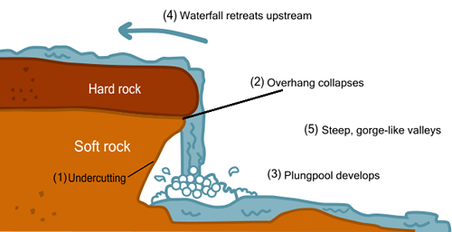

**Erosion landforms: Waterfalls and gorges**

1. Hard rock (limestone) overlies soft rock (sandstone)
2. Soft rock erodes quicker than the more resistant hard rock.
3. Soft rock is eroded by hydraulic action and abrasion and starts to undercut hard rock.
4. Hard rock starts to overhang, until it cannot support itself and collapse.
5. Meanwhile, the base of waterfall is being eroded vertically to form plunge pool.
6. Overtime, the waterfall migrates upstream, forming a gorge.

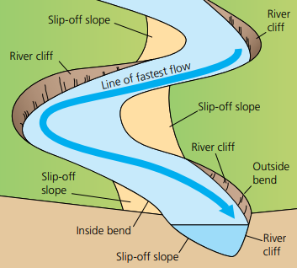

**Erosion and deposition landforms: Meanders**

1. As a river goes around a bend, most of the water is on the outside bend.
2. Fast-flowing water on the outside bank (Thalweg) causes lateral and vertical erosion through abrasion and hydraulic action, which undercuts the bank and forms a river cliff. The vertical erosion deepens the riverbed, resulting in an asymmetrical cross-profile.
3. The inside of the meanders/bends have slow flow of water and high friction, causing deposition of load. This forms a slip-off slope.
4. Overtime, the meander gradually migrates downstream.

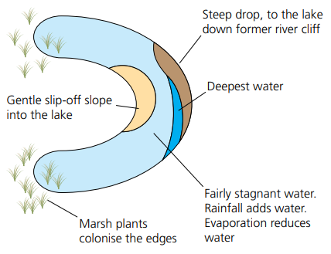

**Erosion and deposition landforms: Oxbow lakes**

**Oxbow lakes** are small, horseshoe-shaped lakes that form in the middle course.

1. The neck of the meander is gradually eroded and becomes narrower.
2. River floods, so main flow of water cuts straight across neck, and the water now takes the shortest route.
3. Flooding causes deposition, which seals off the old meander completely, forming an oxbow lake.
4. Overtime, the water dries up, forming a meander scar.

**Erosion landforms: interlocking spurs**

**Interlocking spurs** are projections of high land that alternate from either side of a valley and project into the valley floor.

1. In the upper course, the river is fast flowing with a steep gradient.
2. If there are areas of hard rock that are harder to erode.
3. The river is not powerful enough to cut through the hard rock, so flows around them.
4. This creates alternating highland called interlocking spurs.

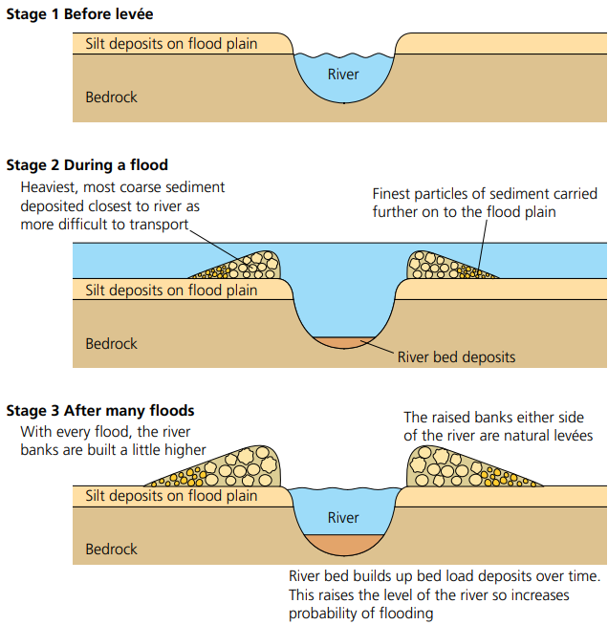

**Deposition landforms: Flood plains and Levees**

A **Floodplain** is flat, marshy land that floods either side of river. (middle/lower course)

1. When a river has very high discharge and floods, the banks burst.
2. Water flows out of the river channel and loses power.
3. This causes deposition of sediment like **alluvium** over a very wide area. (Fertile soils good for agriculture)
4. Overtime, layers of sediment build up through multiple floods, eventually forming a floodplain.

**Levees** are banks of river where deposition occurs. (middle/lower course)

1. When the river floods and burst its banks and the river loses power due to increase friction.
2. Large sediment that the river can no longer carry is deposited on banks 🡪 raised riverbeds along river.

**Deposition landforms: Estuaries and Mudflats**

An **estuary** is the tidal part of a river where freshwater from the river merges with salt water from the sea.

**Mudflats** form in sheltered areas where tidal water flows slowly. As a river transports alluvium down to the sea, a tide transports sand and marine silt up the estuary. Where the waters meet, velocity is reduced, which causes deposition. This builds layers of mud called mud flats (covered at high tide, exposed at low tide).

**Factors increasing flood risk – Human factors**

1. **Urbanisation** – Building on a floodplain creates impermeable surfaces such as tarmac roads, and slate roofs. Water is transferred quickly to drains and then into urban river channels.
2. **Deforestation** – Much of the water that falls on trees is evaporated or stored temporarily on leaves. Trees use water as they grow. After deforestation, water is transferred rapidly to river channels.
3. **Agriculture** – In arable farming, soil is left unused and exposed to the elements for periods of time. This can lead to more surface runoff. This is increased if the land is ploughed up and down steep slopes, as water can flow quickly along the furrows.

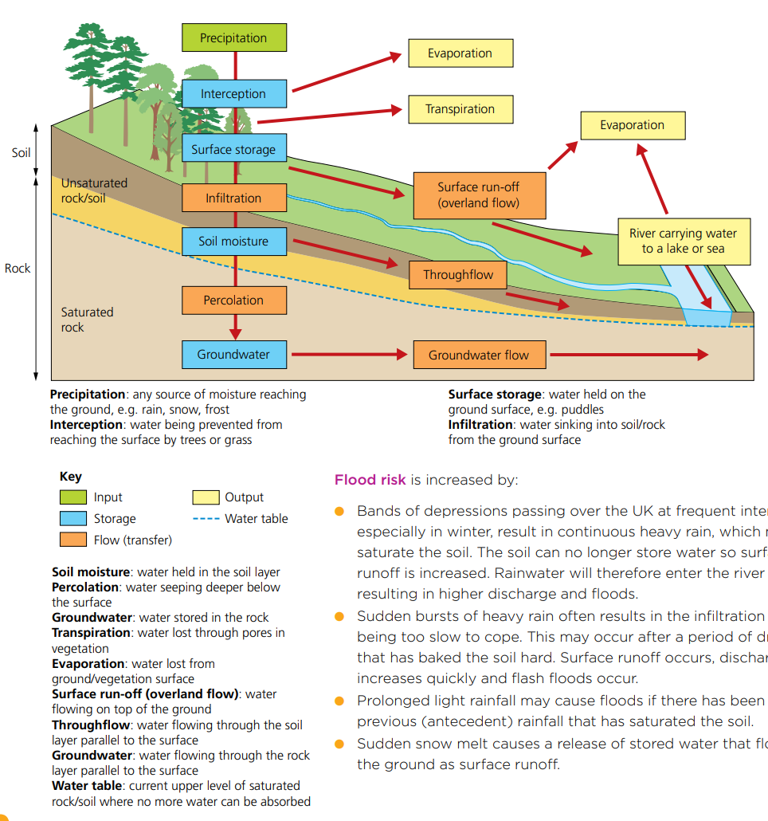

**Factors increasing flood risk – Physical factors**

1. **Precipitation** – torrential rainstorms can lead to flash floods and steady rainfall over several days can lead to flooding in lowland river basins.
2. **Geology (rock type)** – impermeable rocks such as shales and clays encourage water to flow overland and into river channels. This speeds up water flow and makes flooding more likely.
3. **Steep slopes** - In mountain environments steep slopes encourage a rapid transfer of water towards river channels. This increases the risk of flooding.

**Hydrographs**

The shape of a hydrograph is affected by rainfall and by drainage basin characteristics.

**Hydrographs**

A hydrograph shows how a river’s discharge changes in response to a precipitation event. The y-axis measures precipitation (in mm) and discharge (in cumecs – cubic metres per second). The x-axis measures time, the bars represent rainfall, the line graph shows discharge.

**Rising limb:** shows how quickly discharge rises after a rain storm

**Falling limb:** shows the reduced discharge once the main effect of runoff has passed

**Lag time:** the time difference between peak rainfall and peak discharge. Shows speed that water is transferred into channel. The shorter it is the grater the risk of flooding.

**Base flow:** the normal flow of a river when its water level is being sustained by groundwater flow.

**Bankfull discharge:** the level of discharge above which flooding will occur.

The shape of a hydrograph is affected by rainfall and by drainage basin characteristics.

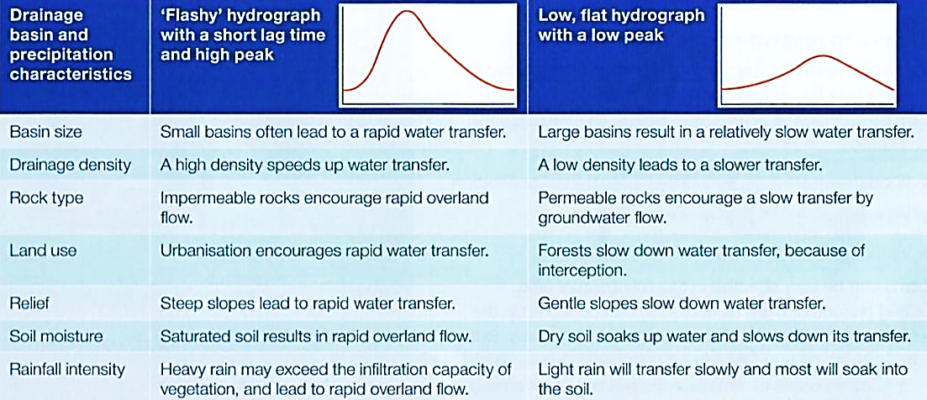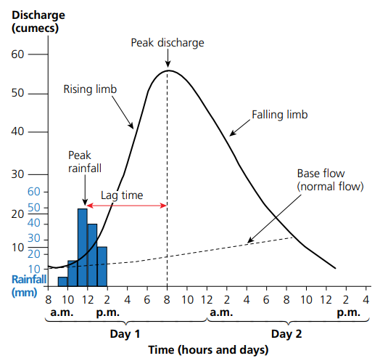

**Soft Engineering**

Soft engineering involves working with natural processes to manage flood risk. It aims to reduce and slow movement of water into a river channel to help prevent flooding.

|  |  |  |  |  |
| --- | --- | --- | --- | --- |
| Method | **Afforestation** | **Wetlands and flood storage areas** | **Floodplain zoning** | **River restoration** |
| How it works | * Trees obstruct the flow of water and slow down its transfer to river channels - interception. * Water is taken up by trees and evaporated from leaves and branches. * Trees roots soak up water and hold soil together, reducing surface run off as ground can become more saturated. | * Wetlands are deliberately allowed to flood, forming storage areas. * This reduces the risk of flooding downstream, where there may be urban areas. | * Restricts different land uses to certain zones on the floodplain. * Areas at risk from flooding can be used for grazing, parks and playing fields. | * When a river’s course has been changed artificially, it can be restored to its original course. * It uses the natural processes and features of a river e.g., meanders and wetlands to slow down flow and reduce the likelihood of flooding downstream. |
| Pros and cons | * It is relatively cheap with environmental benefits. * It **takes time** to help prevent flooding, and it means that the land cannot be used for other purposes. | * It allows natural processes to occur. * This means that the area of land that is allowed to flood cannot be used. | * Can reduce losses caused by flood damage. * Can be difficult to implement on already developed land, and doesn’t stop the flood from happening. | * Often looks much nicer and works with the environment – often providing habitats. * There needs to be sufficient space for this, and it takes time to implement. |

**UK - Somerset Levels Flooding (CASE STUDY)**

|  |  |
| --- | --- |
| Causes | Impacts |
| 1. Heavy prolonged rainfall. December 2013- February 2014, Somerset experienced three times the average amount of rainfall for those months.  Soil became saturated 🡪 more overland flow 🡪 floods easily | **Damage to homes:** more than 600 homes flooded, many forced to evacuate, insurance prices soared and some were unable to insure their homes against future flooding. |
| 2. Lack of dredging. The Environment Agency decided to stop dredging, so had not been dredged regularly for 20 years.  Reduced its capacity 🡪 river fills up quickly 🡪 floods easily | **Transport disrupted:** Villages like Muchelney were cut off by road, Major transport links (A361) closed or disrupted, local companies lost over £1.2 million, loss of tourism cost £200 million. |
| 3. Low lying land. Much of the Somerset levels are only just a few metres above sea level 🡪 land can easily flood | **Farmland was flooded:** 6880 hectares were flooded including farmland, the cost of moving livestock soil was damaged and took 2 years to be restored. |
| 4. Change in farming practices. Much of the land has been converted to grow maize.  Soil is thinner 🡪 cannot store much water 🡪 more overland flow 🡪 floods easily |  |
| Management strategies | |
| The fire brigade used rescue boats to help stranded people in the village of Muchelney. This meant that people who were in villages cut off by the flooding and unable to escape were able to evacuate and get temporary accommodation. However, heating oil and quad bikes were reported from being stolen from the empty properties that had been evacuated. | |
| Environment Agency has dredged 8km of the Parret and Tone rivers. This increases the river’s capacity so enable the river to hold more water and therefore reduced the risk of flooding. Although effective, it is very expensive. | |
| The army and Royal Marines delivered food and sandbags. This provided food to villagers whose own supplies were destroyed. The sandbags meant that people could protect their homes so didn’t need to evacuate. However, providing this aid was only of help in the short-term. | |
| Somerset Levels and Moors Flood Action Plan proposed a tidal barrage and a permanent pumping site (£100 million). These long-term approaches would help to control the water levels in the rivers and thus prevent flooding. Although effective, it can destroy habitats of riverbank wildlife such as otters. | |
| The Met Office issued an amber warning for heavy rain and informed the public to prepare for significant flooding. This meant that residents could prepare for the flooding by using sandbags to protect their homes and moving valuables upstairs. Some residents chose to remain in their property. | |

**Preparing for floods**

In England and Wales, the Environment Agency issues flood warnings at three levels:

1. Flood watch – flooding of low-lying land and roads expected.
2. Flood warning – a threat to homes and businesses.
3. Severe flood warning – extreme danger to life and property.

The Environment Agency produced flood maps showing areas at risk of flooding. People living in these areas should plan for floods by using sandbags and floodgates to prevent water damaging property.

Local authorities and emergency services use flood maps to plan their responses to floods including installing temporary flood barriers, evacuating people, and closing roads.

**Hard Engineering**

Hard engineering involves using artificial structures to prevent, or control flooding. It is usually very expensive, and the costs have to be weighed against the benefits.

|  |  |  |  |  |
| --- | --- | --- | --- | --- |
| Method | **Dams and reservoirs** | **Channel straightening** | **Embankments** | **Flood relief channels** |
| How it works | * Widely used to regulate river flow and reduce risk of flooding. * Often multi-purpose, e.g. HEP (Hydroelectric power) generation, water supply. * Can be effective in regulating water flow and can store water in reservoir. | * Cutting through meanders creating a straight channel, speeding up water flow. But can increase flood risk downstream. * Straightened channels may be lined with concrete. | * Raise the level of a riverbank allowing the channel to hold more water to help prevent flooding. * Concrete or stone walls are often used in towns, though mud dredged from the river can be used. This is cheaper, more sustainable and looks more natural. | * These can be built to by-pass urban areas. At times of high flow, sluice gates allow excess water to flow into the flood relief channel, reducing the threat of flooding. |
| Pros and cons | * It effectively reduces and controls water flow downstream. * Expensive and reservoirs often flood large areas of land. * If it fails it can be catastrophic. | * Speeds up flow. * Concrete can be unattractive and can damage wildlife habitats. * Expensive. | * Increased river capacity. * Can damage habitats when constructing. | * Provides alternative storage. * Very expensive and needs sufficient land. It can also look unattractive. |