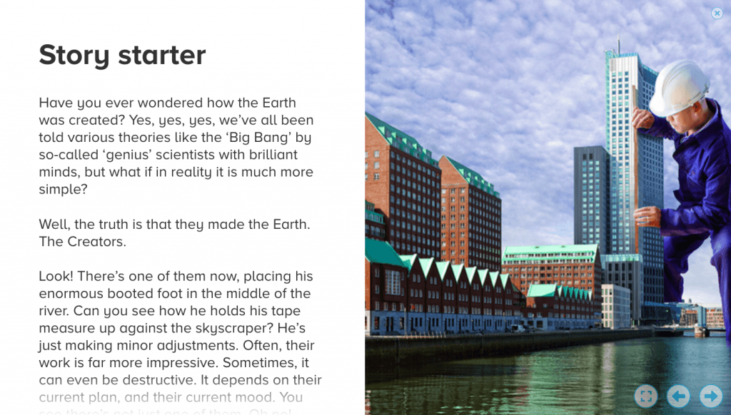
The Creators

They had been here for as long as I could remember. They did not talk nor communicate with us. They did not look at us nor at anything but their work. In fact, I am convinced that they did not even perceive our existence, they purely completed their tasks 24/7. However, the curious part was that we simply acknowledged them, took them for granted and no one really questioned them. If you are struggling to understand, the idea is like a box: it is there to put possessions inside and nothing else. It is simply an object which humbly serves its purpose, and no one truly questions it. To come to think of it, I have never given them as much as a seconds thought, only now has their presence bizarrely occurred to me.
We call them the Creators, for that is their purpose in our world: they plan and construct. When there is need of new grass, they measure and lay out a sheet, when there is need of a house, they construct, when there is… Sorry, you get the idea.
I recall visiting the station a couple days ago; the weather was rather splendid, and the streaks of light came flooding through the railed window, leaving a geometrical print before my feet – masking the rancid, gum-patterned ground. I edged around it while admiring its simplicity, however it was with fruitless effort because a bickering family rode over it a mere second later, thus morphing the image.
Once the train had gotten into its regular chugging procedure, I gazed out from a scratched window adjacent to my shoulder and focussed on a Creator, who was scanning along his tape measure to assess the height of the cathedral. His teal overalls lay flat on his limbs without a single crinkle; he was utterly absorbed in the work with one black-booted foot deep in the River Thames, which compared as a harmless puddle. Resting on his scalp, was a shiny-white helmet with his earlobe barely poking out from underneath, although it seemed to fit. I glanced around to see if a few others were in sight and I spotted several in the background busily working on a park: you see, they were fairly easy to spot – all wearing identical overalls with the same solemn expression. The sweet-tasting streaks of daylight bent around his figure in the gentle way that it does with great buildings and oaks.
Today, I proceeded through the same, monotonous routine as yesterday, and the day before, and throughout my five years working as an assistant. While I do love settling into a routine, I often dream about a life where I could enjoy the complexity of our vast universe and not be forced to say the ten words I despise most in the world: ‘Hi this is Himter Hotel, how may I help you?’. You have no idea how aggravating it can get, especially in that assistant tone of voice.
Today was oddly peculiar. On my way to the office, it was rowdier than usual, as dozens of hushed voices were scattered in abundance across the route, which, ironically, made the chatter louder (I suppose it was the amount rather than volume). The strange thing was that it was not the customary ‘fired, married or promoted’ gossip, but a different, genuine sort, even though I couldn’t hear, somehow, that fact was apparent. I spotted others like me in sheer confusion of it all, eyes gripped on the gossipers, wondering if they could hear, if they could possibly get close enough. It was absolutely unbearable: the idea that the entire world new something that you didn’t (although that was not the case, it sure felt like it).
As I stepped through the double doors, I was determined to find out, and I would most likely be entirely useless until I did. However, the mission was effortless: the news came to me through my colleague – Polly. As her lips pressed together before parting to release the flood that was the rumour, it was like the clapper hit the sound bow, the sprinter leapt over the start line, the bomb detonated. The point of anticipation hit. The waves pounded on my ear drum and my brain processed the signals, yet unable to react. The coal-shaft black heals on my feet wobbled clumsily and I almost plummeted down to the floor, but my desk was just in reach and I grabbed onto it before promptly taking a seat at my chair. The waves flooded into my helpless mind and all at once I gave out a little hummed scream of excitement and was suddenly very aware of my surroundings, but everyone was in their own bubble of emotions, so no one seemed to hear.
Directly behind my desk, was the nearest, and only window in a ten-meter radius. Similar to those public bathroom windows, it was small and circular, perhaps a quarter meter in diameter and incredibly thick. Additionally, the surface was covered in layered dust and the edge where the frame met the glass was filled with filth, it was like the dirt had taken up every crease, dent and hollow in the way that water does. The rim of the glass was stained a murky mustard yellow and the colour crept its way towards the centre like some virus or parasite devouring its host. There, left at the very centre of the window was a small section through which I could watch. I had never truly realised the griminess of this window.
I glared through it to match the picture in my brain and the masses of questions with a reality – it was real, right before my eyes, although I still could not grasp it. Never in my history had I witnessed such a thing. Of course, I had heard about them from relatives, but this was above any expectations. I got nearly so close as to taste the fetid odour, and it was not helping that I had a crowd of people behind me, desperate to steal a glimpse.
After hours of torturous temptation, they finally let us out. I let my eyes feast on the new world, our new world that we were free to explore. And as it turns out, the sky was not the limit this time. It was magnificent.

