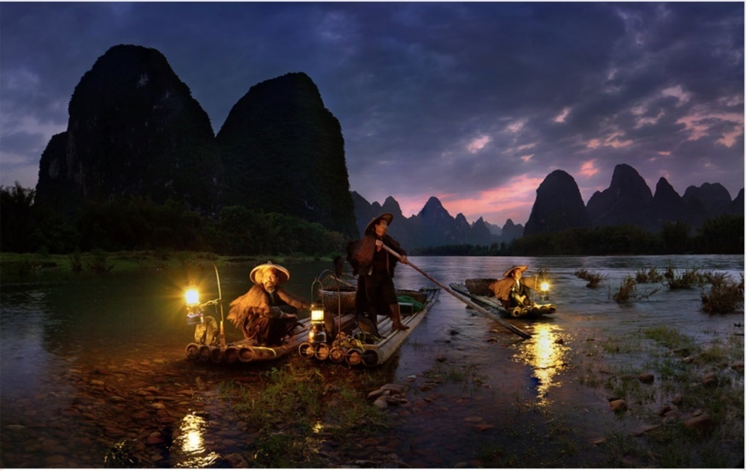**Write the beginning of a short story based on this picture, titled ‘The Journey’**

‘It’s here!’ exclaimed the thin figure in hushed tones, taking his hat to his chest with utter gratefulness. The man standing behind him was slightly larger and plumper with huge portions of bulk wrapped around his limbs. They rushed on to the raft that wobbled before them.

‘Thank God- ‘ murmured the larger of the two while a great sigh escaped his thin lips. ‘-it is here, exactly as described, exactly as they said it would be, ’ he continued. Clambering on, they pushed off from the banks and floated into vast emerald waters that lay before them.

A curled lace of fog rolled in between the mountains and led a trail to their destination, almost as if the transcending forces of nature were there to aid them, to help them complete their journey. From above, the sun still hidden, a darting shaft from the silvered moon came to meet their rosy cheeks, lightening them in the poisoning darkness. This way they could read each other’s lips if their ears missed a few words in their whispers. The mountains appeared just an arm-reach away; they stood tall just like the black shadows of the guardians that will, before long, be after them.

It was a long journey here, and yet nowhere near the end of it.

As the small man rowed with a long branch between his hands, he remembered the beginning of the night. He remembered the plan: get to the raft, pass the barrier, through the… He remembered mouthing *We have to go- we have to get away now, or else they’ll come*.

As he was rowing a horrid memory came to light. Someone in their village had put a toe out of line (the details of their transgressions is something that cannot be said even thought of), and she was tortured so brutally by her own tragic memories. Her saddest memories were brought out, fished out like a buried fossil from the sea of emotions, and replayed in her mind until it was the only one left. It was dreadful. No one could talk to her. No one knew how.

They appeared like some ghost or ghoul – the guardians – with an emanating hypnotising quality that could brain wash their victims, and yet undistinguishable from humans when covered in clothes. It was when their sort of skin was exposed that you could tell, but by that point it was often too late. They made you do unspeakable things, taking control of the mechanisms in your brain. They have the ability to entirely change you, what you think and what you feel.

The two men crouched in silence. They were too filled with their own dreaded thoughts to utter a single word to each other. As the sound of the gentle waters lapping up onto the raft echoed in their ears, the barrier appeared from below the horizon. Although they had heard many stories, the sight before the men still struck them: the image of the lifeless floating fish with their white upturned bellies flashing in the moonlight. This was it.