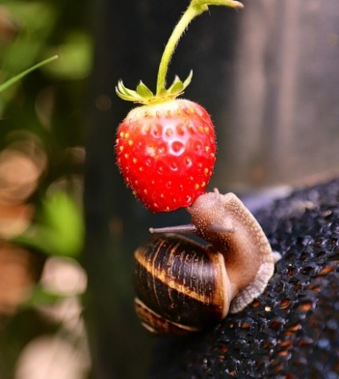
The Life of a Snail
The satisfaction still emanated through him as he sat down to the glorious feast that his mother had so carefully, and with such meticulous precision, prepared for her only son – her angelic son. It pulsed through his body, boiling deep inside of his vermillion heart; it lighted a black fire inside that was hidden with electrifying secrecy, yet its smoke filled his mouth. He was helpless in controlling the wide smile that spread across his face, but the reality was that he didn’t want to control it. Letting the power take control, letting it suffuse to his fingertips, he extended his slouched body upright. He could reach for the clouds. He could crush them with his own bare hands.
He grabbed something from each dish placed before him: a drumstick, a slice of turkey breast, some bread with pastrami… The white porcelain plate was covered with a mess of golden meat roasted, fried or grilled, and a mixture of tantalising aromas wafted up, smacking his face with glory. It was his reward, he felt, for his brutal victory.
Before he could take a bite, a fat pile of mashed potato sloped onto the last area of white visible on the plate. Splattered like a putrid thick blood, the mash resembled something of his previous victim, and as he reminisced the surge of adrenaline overflowed into his brain.
Delicious. That was simply delicious. She very rarely came across a strawberry so big, so sweet and so exceedingly ripe but whenever she did, she always made the most of it. After searching for an eternity, she had finally found one that she could reach. And it was perfect. It hung on its stem so low and weightily, drooping down like an over-filled water balloon on the verge of bursting. In that first bite the tang of sour sugar exploded like dynamite in her mouth – that had to be what heaven tasted like.
He was prowling through the area behind the strawberry patch, stamping on every dead leaf just to hear than satisfying crunch. Galloping like a horse, bouncing up and down and up and down, he flattened every inch of the garden, tasting delight from every jump. The air was rich with the intoxicating smell arising from the oven, as he played bubble-wrap pop with the bubbles of nature: each bubble popped fuelled his need for destruction more and more and more. Pop! Pop! Pop!
As he attempted to locate which vulnerable mahogany leaf would result in the biggest ultimate crunch, instead a different prey aroused his attention – the snail. She was lying there completely isolated and clearly oblivious to the world. She made her way to a shaded area away from the harsh exposure of the sun-lit patio in order to re-join her brothers and sisters. This was clearly the opportunity he had been waiting for.
She never made it back to her siblings.
Her beautifully sculpted caramel-beige shell – a work of art by nature’s steady hand – was now scattered across the ground like shattered porcelain and her body squashed to a pulp with the red of her lunch spewing out like blood. Waiting for the soil to take her in, it wouldn’t be long until she was erased from history, with no traces bar the thin trail of broken silvery-white.

