Geography – Weather Hazards

**Global atmospheric circulation**

* Global atmospheric circulation is the transfer of heat from the equator to the poles by the movement of air.
* Air moves due to differences in air pressure – winds blow from high pressure areas to low pressure areas.
* The global atmospheric circulation system is divided into loops, called cells, each cell has warm rising air that creates a low-pressure belt and cool sinking air that creates a high-pressure belt.
* Each hemisphere has three cells.

1. The sun warms the earth at the equator 🡪 Air rises 🡪 low pressure belt. 🡪 Equatorial low
2. As the air rises it cools and moves away from equator.
3. 30° north and south 🡪 cool air sinks 🡪 high pressure belt. 🡪 Subtropical high
4. At ground surface, cool air goes back as **trade winds** OR up as **westerlies**.
5. 60° north and south 🡪 warmer surface winds meet cold poles 🡪 low pressure belt 🡪 Subpolar low
6. The warm, rising air moves back to equator OR towards the poles.
7. At the poles 🡪 cool air sinks 🡪 high pressure belt 🡪 Polar high
8. The high-pressure air is then drawn back to the equator.

**The Coriolis effect**

Trade winds, Westerlies and Polar Easterlies curve because of the Earth’s rotation – the Coriolis effect.

**Weather**

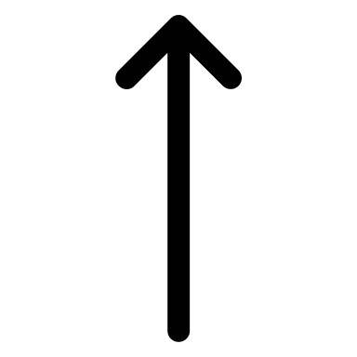RISE LOW RAIN 🡪 CYCLONE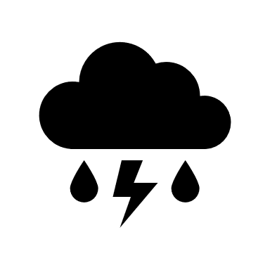

SINK HIGH CLEAR 🡪 ANTICYCLONE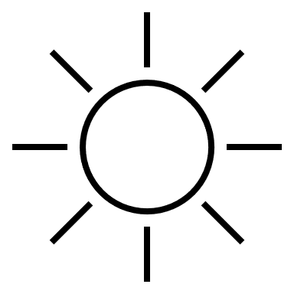

1. **At the equator**, the sun is directly overhead – it receives a lot of insolation – so it is hot. Warm, moist air rises, so it rains a lot. 🡪 rainforests form
2. **At 30° north/south**, air has released all moisture, so it is dry 🡪 deserts form
3. **The UK is near subpolar low at 60° north**. Warm rising air from the equator rises, so it rains a lot and is cloudy. Also cold as cold polar air is drawn down.

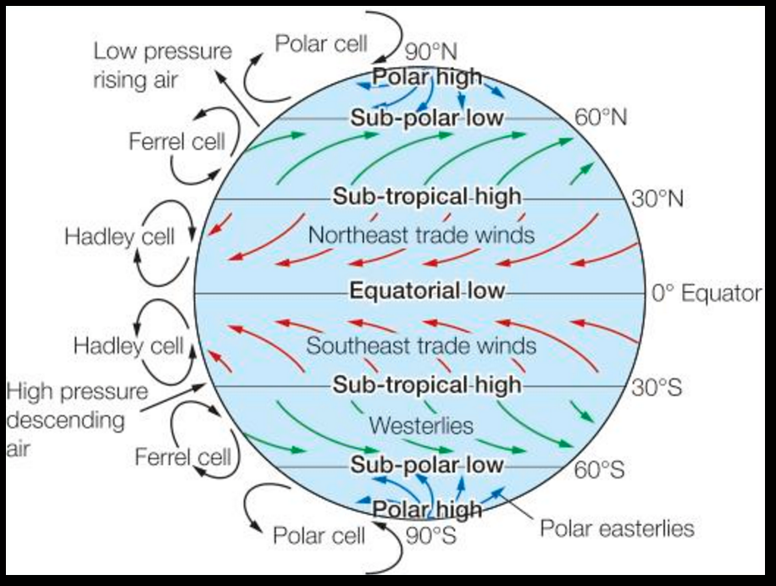

Tropical storms – How and What?

Tropical storms are intense low-pressure weather systems with heavy rain and strong winds that spiral around the centre. They NEED:

* Warm waters 27° or higher 🡪 supplies moisture
* Intense heat and humidity 🡪 make air unstable and rise
* High Coriolis effect 🡪 spinning
* Low wind shear prevents clouds breaking up as they rise, so the storm stays intact.

FORMATION:

1. Warm surface water evaporates, rises, and condenses 🡪 Low pressure & release of latent energy.
2. Trade winds from opposing directions rush in and storm starts to spin 🡪 Coriolis effect.
3. Cooler air is sucked downward creating an eye at centre and wind speeds increase.
4. Prevailing winds move storm and warm waters strengthen storm.

Tropical storms – Features

Tropical storms are circular in shape, hundreds of km wide and last 7-14 days. They spin anticlockwise in the northern hemisphere and clockwise in the southern hemisphere. They form between 5° and 30°.

* EYE – The centre, up to 50km wide, clear conditions and it is caused by descending air.
* EYEWALL – Spiralling rising air, very strong winds (160km/h), storm clouds, torrential rain, low temp.
* EDGES – Wind speed falls, smaller clouds, less intense rain.
* RAIN BANDS – Bands of dense condensed air where clouds form.

Tropical storms – Where and When?

The majority in northern hemisphere occur from August to October, in southern hemisphere from December to April.

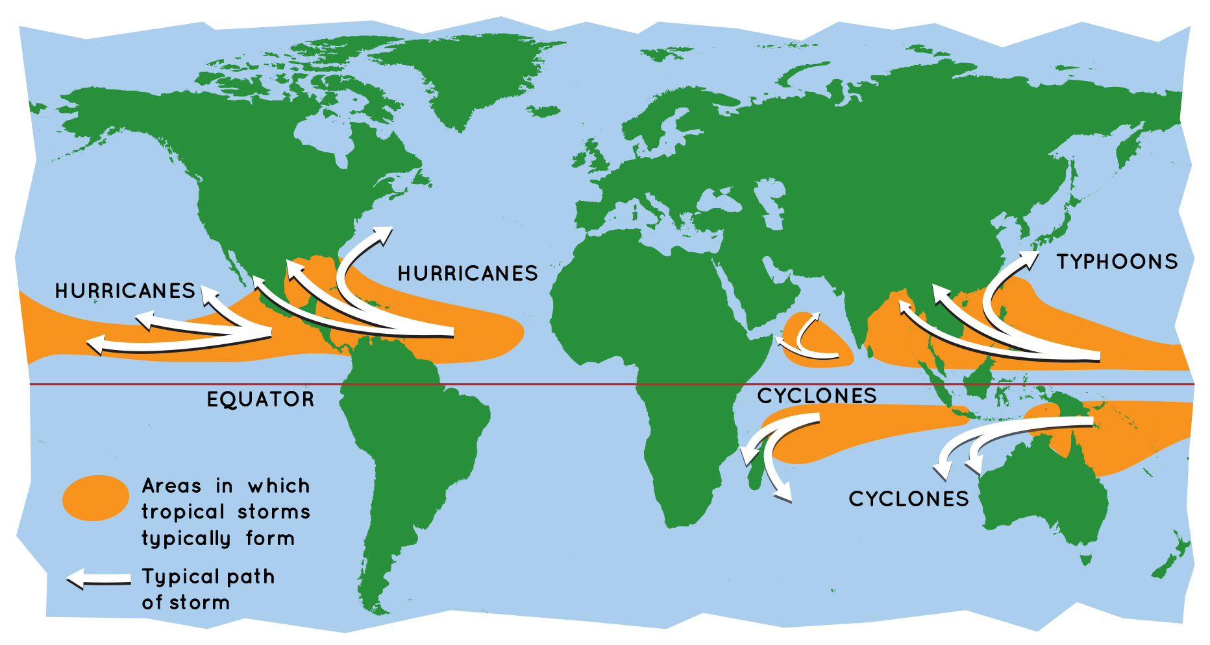

* Atlantic Ocean 🡪 HURRICANES
* Indian Ocean 🡪 CYCLONES
* Pacific Ocean 🡪 TYPHONNS
* The majority of storms are found by the tropics.
* Typhoons are located East of the Pacific Ocean.
* Hurricanes are located in the Atlantic Ocean.
* Cyclones are located in the Indian Ocean.

**Key Words**

**Insolation** – Incoming solar radiation from the sun.

**Coriolis effect** – Trade winds, Westerlies and Polar Easterlies all curve due to the rotation of the earth.

**Prevailing wind** – The most frequent wind direction a location experience. In the UK it is from South West.

**Saffir-Simpson Scale** – A scale of 1 to 5 based on a tropical storm’s sustained wind speed.

**Tropical storm** – An area of low pressure with winds moving in a spiral around the calm central point called the eye of the storm.

**Trade Winds** – Winds blowing towards the equator from Northeast and Southeast that curve due to the Coriolis effect.

**UK - Somerset Levels Flooding (CASE STUDY)**

|  |  |
| --- | --- |
| Causes | Impacts |
| 1. Heavy prolonged rainfall. December 2013- February 2014, Somerset experienced three times the average amount of rainfall for those months.  Soil became saturated 🡪 more overland flow 🡪 floods easily | **Damage to homes:** more than 600 homes flooded, many forced to evacuate, insurance prices soared and some were unable to insure their homes against future flooding. |
| 2. Lack of dredging. The Environment Agency decided to stop dredging, so had not been dredged regularly for 20 years.  Reduced its capacity 🡪 river fills up quickly 🡪 floods easily | **Transport disrupted:** Villages like Muchelney were cut off by road, Major transport links (A361) closed or disrupted, local companies lost over £1.2 million, loss of tourism cost £200 million. |
| 3. Low lying land. Much of the Somerset levels are only just a few metres above sea level 🡪 land can easily flood | **Farmland was flooded:** 6880 hectares were flooded including farmland, the cost of moving livestock soil was damaged and took 2 years to be restored. |
| 4. Change in farming practices. Much of the land has been converted to grow maize.  Soil is thinner 🡪 cannot store much water 🡪 more overland flow 🡪 floods easily |  |
| Management strategies | |
| The fire brigade used rescue boats to help stranded people in the village of Muchelney. This meant that people who were in villages cut off by the flooding and unable to escape were able to evacuate and get temporary accommodation. However, heating oil and quad bikes were reported from being stolen from the empty properties that had been evacuated. | |
| Environment Agency has dredged 8km of the Parret and Tone rivers. This increases the river’s capacity so enable the river to hold more water and therefore reduced the risk of flooding. Although effective, it is very expensive. | |
| The army and Royal Marines delivered food and sandbags. This provided food to villagers whose own supplies were destroyed. The sandbags meant that people could protect their homes so didn’t need to evacuate. However, providing this aid was only of help in the short-term. | |
| Somerset Levels and Moors Flood Action Plan proposed a tidal barrage and a permanent pumping site (£100 million). These long-term approaches would help to control the water levels in the rivers and thus prevent flooding. Although effective, it can destroy habitats of riverbank wildlife such as otters. | |
| The Met Office issued an amber warning for heavy rain and informed the public to prepare for significant flooding. This meant that residents could prepare for the flooding by using sandbags to protect their homes and moving valuables upstairs. Some residents chose to remain in their property. | |

**Typhoon Haiyan – Philippines (CASE STUDY**

November 8th, 2013, 4:40 AM, Category 5, Wind speeds 200mph, Wave height 15 feet, Storm surge height 20 feet. Philippines: LIC, Locals were used to typhoons (already had 14 in the season), Locals didn’t consider effect of the storm surge.

|  |  |
| --- | --- |
| Primary Effects | Secondary Effects |
| 8,000 people died - social | The lack of clean water caused outbreak of dysentery – social |
| 90% of Tacloban destroyed and over 1 million homes severely damaged - social | Flooding triggered several landslides, which blocked roads and delayed aid –environmental |
| Heavy rain and storm surge flooded 600,000 hectares of farmland – environmental and social | 5.6 million workers lost their jobs as businesses were destroyed – economical |
| 13 million dollars’ worth of damage - economical | Looting and violence in Tacloban – social |
| Immediate Responses | Long-term Responses |
| PAGASA (meteorological agency) broadcast warnings two days before. 800,000 evacuated. | The UN appealed for over 300 million dollars to help fund rebuilding and relief. |
| US helicopters assisted in search and rescue. | Charities built new storm-resistant houses. |
| Over 1200 evacuation centres set up. | Homes were rebuilt in safer areas |
|  | Rice farming and fishing quickly re-established. |

Monitoring/ Prediction

* Hurricane Hunters 🡪 fly into tropical storms to gather weather data. **Dropsondes** measure pressure, wind, temp., and humidity. It is the most accurate info, but difficult to predict intensity.
* Satellites 🡪 they watch hurricanes form, taking images of clouds and measuring weather patterns with **radar** and **infrared sensors**.

Climate Change

Climate change will affect distribution, frequency, and intensity of tropical storms.

* **Distribution** 🡪 Average ocean temperatures rise, more of world’s ocean are above 27°C. Tropical storms can form in areas that they have not before.
* **Frequency** 🡪 Oceans will stay 27+°C for longer each year. In Atlantic the number of tropical storms each year increases.
* **Intensity** 🡪 Higher sea surface temperatures fuel more energy to storms. In Atlantic, the number of major hurricanes has increased.

Protection

* Building design 🡪 Stilts, raising electrics, built away from rivers, cyclone shelters.
* Storm drains 🡪 prevent flooding
* Shutters built over windows

**Extreme weather hazards in the UK**

* Weather 🡪 Day-to-day conditions of the atmosphere e.g. temperature, precipitation
* Climate🡪 The average weather over a 30-year period.

|  |  |  |
| --- | --- | --- |
| **Hazard** | **Impacts** | **Example** |
| Strong Winds | Gales can damage properties and disrupt transport. Uprooted trees and debris can injure people. | 2018, Storm Ali 🡪 winds 100mph, 2 deaths, uprooted trees. |
| Heavy Rainfall | Flooding can damage homes, disrupt transport networks, and drown people. | 2020 October, Storm Alex 🡪 Wettest recorded of 3cm average over UK. |
| Snow and Ice | Injuries caused by ice and death due to cold. Disruption to travel, schools and businesses closed. | 2018 February/March, Beast from the East 🡪 50cm of snow, causing traffic disruption. |
| Drought | Water supplies run low causing crop failures. Hosepipe banns. | April 2010 to March 2012 🡪 England received 75% of av. rain. |
| Thunderstorms | Heavy rains and flash floods. | Boscastle in Cornwall 2004 |
| Heatwaves | Heat exhaustion and breathing difficulties can cause premature deaths. Disruption to transport. | Heatwave of 2019 🡪 temperatures in Cambridge reached 38.7°C. |

Weather becoming more extreme 🡪 Extreme events seem to be becoming more common and severe

* **Temperature:** UK’s 10 warmest years have occurred since 1990, seven of UK’s eleven coldest temps has occurred since 1980, December 2010 was coldest month for over 100 years.
* **Rainfall:** Most rainfall records broken between 2010 and 2014, major flooding events are more frequent, October 2020 was the wettest day recorded.
* Mexico

Preparation

* Education 🡪 people are educated in schools about the dangers of tropical storms. Training local people to organise others into evacuation.
* Evacuation 🡪 reduce death toll.
* Emergency kits 🡪 to be ready for sudden hit.