**How to revise from resources:**

1. Do not revise whole huge sections at once, just focus on small sections e.g. River erosional and depositional landforms.
2. Read through that part of the revision document carefully and first make sure you understand it (e.g. if there are some terms that are unfamiliar to you, then look it up).
3. Then read through it again and highlight key words only (**not** the whole thing) that effectively help you to remember a key point.
4. Make a flashcard based on this (the key thing is not to simply copy the text because you want to try to have as little text as possible really on them, it’s good to include diagrams and symbols e.g. TMT, ↓, 🡪, ∴)

**Erosion landforms: Waterfalls and gorges**

1. Hard rock (limestone) overlies soft rock (sandstone)
2. Soft rock erodes quicker than the more resistant hard rock.
3. Soft rock is eroded by hydraulic action and abrasion and starts to undercut hard rock.
4. Hard rock starts to overhang, until it cannot support itself and collapse.
5. Meanwhile, the base of waterfall is being eroded vertically to form plunge pool.
6. Overtime, the waterfall migrates upstream, forming a gorge.

Explain the 6 steps in the formation of:

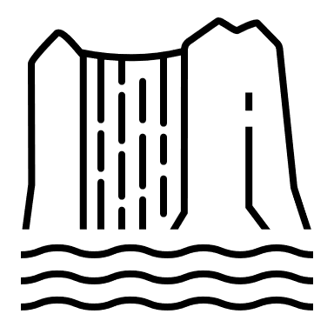

1. overlies 
2. erodes quicker
3. -action + abrasion = undercut
4. overhangs 🡪 collapse



1. Base eroded 🡪
2. Migrates ↑ 🡪 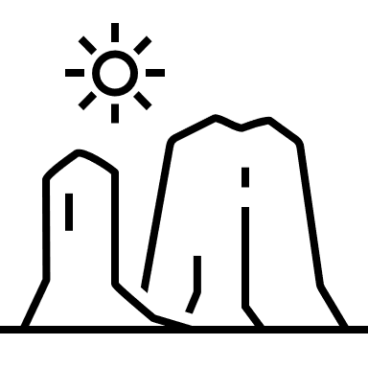

**Getting ready for the exam**

* Know the exam TIMINGS, STRUCTURE, and which PARTS you need to answer. Don’t be the person who answers all the questions.
* It’s a good idea to have a piece of string in your exam pencil case because sometimes there can be diagrams on which you need to measure curved distances, which can be difficult with a ruler.

**Using Practice Papers**

*Especially in Geography, this is the best way to consolidate your knowledge, and by repeatedly using practice papers as revision (even for topic tests in class) by the time you get to your GCSE, you will be able to know exactly what you need to write to get 100% in every question. This is what you can do to get the most out of practice papers.*

* Don’t focus on time management at first. As you do more and more papers, you can start to look at time and you will see you get faster every time.
* USE MARK SCHEME! Using the mark scheme straight after you do the paper is important because that way you still have your answers in your mind and can clearly make links in your head on how to improve your knowledge. Use a different coloured pen, and don’t just write down everything that is written on the mark scheme also because that won’t help you when you look over it as revision. Instead read the mark scheme and for every question, pick out the main points (there will often be a list of appropriate answers) that you understand and think you can remember (since you can’t remember everything in the mark scheme, it also better engages your mind because you read and comprehend the correct answers better).
* This process of doing the paper and then spending a lot of time marking will take up a large part of your revision, but it is really effective. You can then add mistakes you made onto your flashcards or make new flashcards specifically for exam practice mistakes.
* If you have already done a lot of practice, and simply want to refresh your memory before the exam, you can still use practice papers, but instead of writing out long answers, just write bullet points for long 6/9-markers to save time e.g. which case study you’d use, statistics, development of answers using 🡪.