Language Paper 2, Question 3

You now need to refer only to **Source A/B** from lines...

How does the writer use language to describe…?

* Person/Character
* Experience
* Setting
* Feeling

`

(12 marks)

Time: 15 minutes

<https://www.youtube.com/watch?v=RUWxpg_EmeM>

<https://www.youtube.com/watch?v=rcOLjUvqYCE>

<https://www.youtube.com/watch?v=j6vbvss1rxM>

Mark scheme:

**What you need to do**

To get full marks, you need to go further than just simply stating a language technique and giving a basic effect. You need to focus on the specific effect that the writer creates with a technique and why the writer includes it.

1. Make a point about the use of language (include the language technique)
2. Find quotations to back up your answer
3. Explain the specific effect and the writer’s purpose



Mr Bruff’s example:

Thompson uses a range of **negative emotive language** to describe Adrian, detailing the ‘poor behaviour exhibited’ by the boy. The use of the verb ‘exhibited’ has an extra layer of criticism to it, as it suggests that Adrian’s bad behaviour is some sort of public spectacle, a performance given for the purpose of eliciting a response. It is as if the boy has deliberately misbehaved, rather than accidentally fond himself in trouble. This exaggerates the sense of Adrian’s disobedience. This **negative emotive** language is juxtaposed by a wealth of positive terms used to describe Woodland Green school. Thompson employs a range of **positive adjectives** such as ‘keen’, ‘eager’ and ‘best’, juxtaposing the negative description of Adrian with the positive description of the school to emphasise just how wonderful the school is and just how disobedient Adrian is.

Examiner’s report

* Students have demonstrated a better choice of language examples in their responses.
* Performance on question 3 has improved, with almost half of students gaining level 3 or above.
* Students should focus on specific, contextualised responses rather than generic or generalised comment.
* Exploring the ‘big ideas’ in texts supports students in reaching the higher levels.

**Key tips**

1. Be specific about the effects the writer’s language choices have and explain a reason behind the writer’s choices.
2. Your writing needs to be precise and contextualised to the extract.
3. Ask yourself: What is the specific effect that the writer is trying to achieve?
4. Your explanations suggest alternative interpretations, or more than one idea.
5. Use tentative language.

Mark Scheme Level 4 answer

The phrase ‘sucked into the belly of the wave’ effectively portrays the sea as a greedy monster, the use of personification suggesting the sea has an insatiable appetite. The curling motion of the wave as it engulfs him is reflected in the metaphorical image of the wave’s rounded ‘belly’ as he is consumed by the ravenous sea. In ‘sucked’ the writer chooses a short, single syllable verb to echo the speed with which he was suddenly plucked out of the boat and into the water, by the relentless strength of the ocean.

June 2017 my example answer:

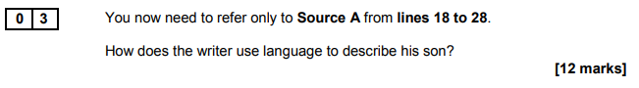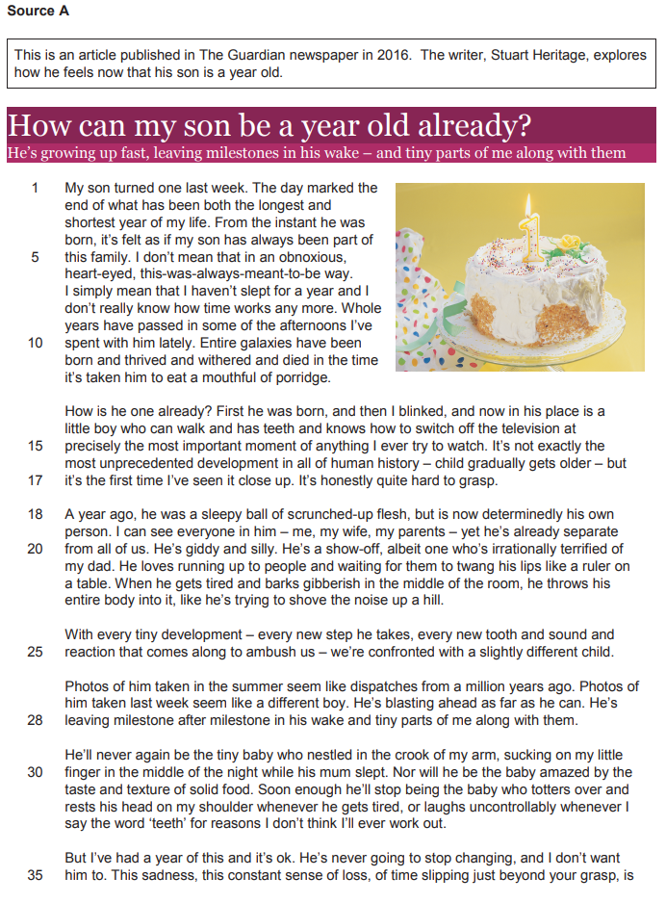

In the extract, the writer uses a range of different language skills to describe his son in the past as an ordinary and adorable new-born baby. By comparing his son to ‘a sleepy ball’ in a metaphor, the writer creates a visual image of how sweet his young son was in the reader’s mind. This conveys the innocence and youth that he had since it reminds the reader of the position he would be in his mother’s womb before birth. Furthermore, the use of the noun ‘ball’ – an inanimate object – portrays how he may have been limited in his actions and could do nothing but sleep when he was younger. The noun phrase ‘scrunched-up flesh’ highlights the idea that he was nothing more than an unidentifiable infant, much like any other. The writer may have chosen to use these language techniques to later contrast the way his son has grown to be an individual, and to explore the bigger ideas of how growing and changing children affect their parents.

The writer further describes the son using adjectives ‘giddy and silly’, which depicts him as young and immature, providing the reader with the image of a very energetic and active toddler. Furthermore, through the adverb ‘irrationally’, we can understand that his actions and thoughts stem from strange reasoning, highlighting the fact that he is unable to explain himself and his thoughts yet. This is furthered by his attempts in saying something, which is described with the simile ‘like he’s trying to shove the noise up a hill’, suggesting that he is both loud and exaggerates his actions.

Moreover, the writer employs the semantic field of space exploration to portray his son as distant, baffling and continually changing, much like the development and journeying into space. This is indicated through the phrases ‘dispatches from a million years ago’ and ‘blasting ahead’, both conjuring images of fast and limitless travel. In the simile, where the father compares old pictures of his son to ‘dispatches’, he implies how far away he feels from these past versions of his son, and therefore sees photos of his son almost like statistical reports which he cannot recognize. Coupling this with the hyperbolic language in ‘a million years’, displays the writer’s incomprehensibility, and therefore depicts the son as someone who has grown so much since ‘the summer’, developing into a complex individual. Furthermore, through the verb ‘blasting’, the writer is perhaps comparing his son to a fast rocket, both describing his son as something that he cannot understand and as something that will go beyond his control very quickly.

June 2018 my example answer:

Bird uses language to describe the surfers with great importance, almost resembling royalty. Through the sematic field of royalty in ‘rode in majestically’, Bird depicts them to be worshiped by the sea, elevating their superiority by almost personifying the waves as their subjects. The verbs ‘rode’ and ‘carried’ demonstrate that the surfers don’t need to put in any effort in gliding over the water, since it acts like a transport mechanism, reflecting how soldiers would be ‘carried’ by their horses. Furthermore, the surfers are ‘daring riders’ implying that they are thrill seekers, who wish to explore different experiences, even if that means risking their lives. This coupled with the phrase ‘fresh exploits’ highlights their need for a bold and daring feet. However, the verb form of, exploiting, has connotations of the surfers utilising the sea for their own gain, and since the sea is personified, it makes the reader feel empathy for it.

Mr Salles model answer: (from Nov-2020 paper)

Simpson feels terrible pain and fear which is why he describes the sliding as terrible. Next, he uses sibilance to emphasise both his relief that the pain has temporarily stopped, because the sliding has stopped, but also to emphasise his sense of fear about the sinister implications of his injury, not just the long-term damage to his knee, but the possibility that the descent will end in further tragedy on the slope.

He uses metaphor to dramatize the extent of the extreme pain he is suffering. ‘Nausea overcomes him like a wave’, which then ‘swept over’ him as though he could not resist it. However, he next describes the snow as ‘painfully biting into my face’. This metaphor suggests that he is actually grateful for an alternative source of pain to take his mind off the ‘agony’ in his leg. Rather than overwhelming him, this pain is localised ‘into my face’ which gives him the confidence that this is a pain he will be able to endure. We also get the sense that he’s happy to have something to distract him, no matter how painful.

The next metaphor describes his pain as a ‘flare of agony’. A flare is used as a warning, or a cry for help and we can infer that he feels desperate for assistance and also desperate that he worries the pain is too great to survive his ordeal on the mountain. He also returns to sibilance as a way to dramatize his worry at the sinister turn of events when he concentrates on the damage inside his knee. His joint ‘seemed to shear’ which both suggests that the damage is long term but also that he will be reduced to only using one leg in this dangerous descent of the mountain, which might lead to further tragedy. He uses a pair of adjectives to describe his anxiety at the ‘crunch’ in his knee which is both ‘sickening’ and ‘gristly’.

Next Simpson uses the alliteration of ‘barely’ ‘sobbing before and boot’ to emphasise the beats of pain he is getting ever stime his ‘boot gets snagged’. This implies that he is feeling overwhelmed with the pain and doesn’t feel he will be able to escape it or manage it. Even when this is over at the end he focusses on the effect on his leg, which ‘shook uncontrollably’. This adverb implies that he is fighting for control but unable to establish it. He emphasises this by returning to the idea in the next sentence with the contrast ‘but the harder I tried the more it shook’. This conveys a sense of helplessness that he is not going to be able to control either his own emotions, or his pain, or indeed how his body reacts.

However, the paragraph ends with him trying to take control of his body, where he gritted his teeth and then waited. This determination appears to work. Consequently, he ends the paragraph with a four-word sentence. This dramatic conclusion emphasises his newfound control as the pain ‘eased’. This allows us to imagine his feeling of hope in contrast to the earlier feelings of helplessness. This makes sense given the fact that we know he eventually survives, as he is writing this account.