Language Paper 2, Question 5
Write a … arguing your point of view in response to this statement
- Letter
- Article
- Essay
- Speech
(40 marks – 24 marks for content and organisation,
16 marks for technical accuracy)
Time: 45 minutes
https://www.youtube.com/watch?v=wrn_2qM6syI
https://www.youtube.com/watch?v=B1aONhs0SC4
https://www.youtube.com/watch?v=jurpjpuWMj4
https://www.youtube.com/watch?v=n-4cXvVO1Zs

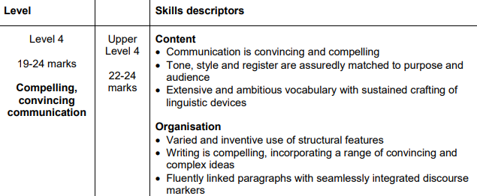
Mark Scheme:
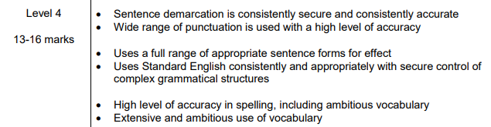

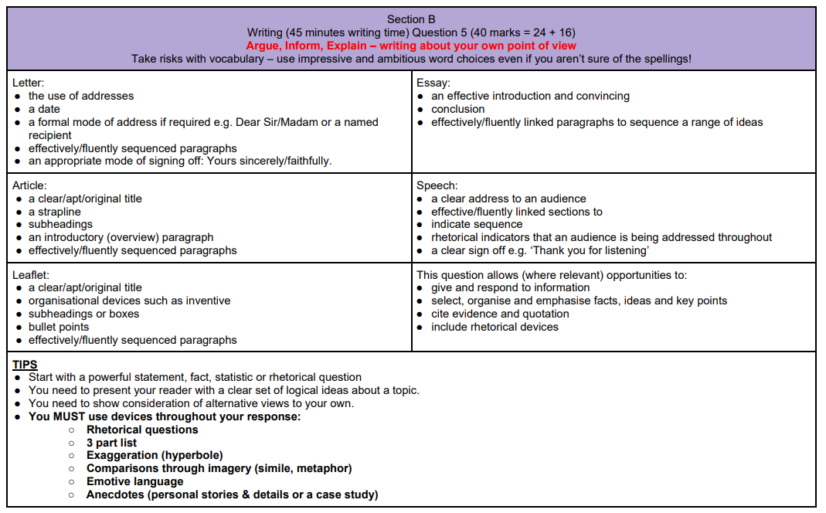
Things you can include
- Start with emotive imagery, short and long sentences
- Include one sentence paragraphs that go BIG and relate your argument to a big issue
- Repetition of words in sentences for effect
- Anecdotes
- Adopt a different persona (the persona of the person who would argue against you) and address the reader directly – use brackets to show you/the writer’s thoughts.
- Alien perspective: In fact, if you were an alien visiting Earth for the first time you would be utterly confounded as to why so many of the world’s societies have made shrinking themselves their main preoccupation in life.
- End with writing about the future: e.g. Imagine we started obsessing about things we loved about ourselves. The future wouldn’t be as bleak. What a wonderful world that would be. No starvation necessary. We can dream.
- Cyclical structure

- Convincing: good arguments to support your case
- Compelling: range of techniques
- Register matched to purpose and audience: Letter, article, essay…
- Structural features: link beginning and ending, use a one-line paragraph, vary sentence lengths
- Discourse markers:
  - Of course…
  - Consequently…
  - In addition…
  - Not only this… but…
  - Correspondingly…
  - By/In contrast…
  - In my opinion…
  - What is more…
  - In conclusion…
  - Finally…
  - Nevertheless…
  - As a result…
- Ambitious vocabulary:
  - Exuberant
  - Panacea (solution for all problems)
  - Cynical, abhorrent, heinous
  - Elated
  - Gluttonous
  - Meticulous
  - Morose (gloomy)
  - Clandestine (adj, secret/sly)
  - Arcane (known or understood by very few: mysterious, obscure)
  - Archaic (primitive, ancient, old)
  - Plethora (overabundance, excess)
  - Audacious (reckless, bold, daring)
  - Indignant
  - Euphoric
  - Colossal, gargantuan
  - Bemused, befuddled
  - Astute, shrewd
  - Feeble, decrepit
  - Cordial
  - Lackadaisical
  - Paradoxical, outlandish
MADFATHERSCROCH
- Metaphor,
- Alliteration,
- Direct Address,
- Facts,
- Anecdote,
- Triplet,
- Hyperbole,
- Emotive Language,
- Rhetorical Language,
- Connotation,
- Repetition,
- Opinion,
- Time,
- Create Enemy,
- Humour
Mr Salles Example paragraphs
Show me a brilliant parent, and I’ll show you a child who once learned to love and cherish a pet.
A child’s life is shaped and sculpted by love and responsibility, and a pet is like an artist’s hand, carving out a future parent, one able to meet the challenges parenting brings. Because no one trains you to be a parent, do they? Children and pets don’t come with a manual, but with a warning: ‘Handle with care: may bite!’
Not only will a pet show you the rich rewards of loving another being who dotes on and depends on you, but it will also help you deal with the less pleasant experiences of routine, trust and duty. Those rainy days, when the dog begs you with whining, tapping paws and beseeching eyes, and you just have to pull your cap down, turn up your collar and fight the cold are no different to the grey Sunday morning when your toddler’s eyes light up at the puddles, and you have to let them jump in, splashing you again, and again, and …
…you get the idea.
Examiner’s Tips
- Planned an argument, with a sequence of points that build on each other
- Write a summary of their argument in a single sentence. If this idea is established in the opening paragraph and confirmed in the concluding paragraph, it’s more likely that the student will maintain a greater degree of discipline in the intervening points.
- Address just one or two of the strands in the statement and to write in more depth about each. Students who are able to offer extended ideas, particularly if they became more complex as they develop, are more likely to achieve higher marks.
- The best responses are characterised by students engaging with the ‘big ideas’ (politics, economics, gender, aesthetics, class, morality, psychology, philosophy) and framing their own perspectives in this larger context, enhancing the overall quality of their argument.
- Keep it shorter – 3 sides maximum
- ‘The clarity, or otherwise, of the argument is the first and most important judgement made by the examiner and determines the overall level awarded, followed by a detailed assessment of the individual skills in evidence.’ (June-19 report)
- Students are not required to cover every thread in the statement in their response; selecting one or two threads can lead to a clearer argument (Nov-19 report)

Mr Salles tips
- Start each sentence with a different word
- Write about the future
- Not only…but
- Show me…I’ll show you
- Pair your verbs for emphasis
- Extend your simile or metaphor
- Anecdote
- The contrasting power of ‘but’
- Humorous comparison
- Lots of triplets

How to plan
Use the 5 whys technique – in each paragraph, question every point you make with a ‘why is that important?’ until you can get to a sophisticated point with cultural capital (e.g. society, poverty, religion, philosophy…)
- INTRODUCTION 2-3 sentences:
  - Start with a captivating descriptive or scenario sentence
  - Summarise your 3 key strong points
- POINT 1/2/3
- COUNTERARGUMENT
  - This can be within your other agree points
- CONCLUSION:
  - Simple, concise and memorable
  - Sum up your view, and link to the cultural capital, thinking of the wider global effect of your argument by exploring bigger ideas.
SENTENCE STARTERS
- Nevertheless, there are many of you who will disagree…
- Furthermore, we should not forget that…
- Consider…
- The argument around whether…is a perennial issue
- Worse still…
- Consequently, …
- In the past…
- Firstly,Secondly…
- Imagine each day you woke up…
- Picture this: … That is what…experiences on a daily basis
- Even if…
- That being said, it cannot be denied that…
- Imagine a future where our children and grandchildren can/can’t…
- Can we really afford to accept the price of the status quo?
- Do we want to be remembered as the generation who (something negative), or the visionaries who (something positive)?
- Seemingly illogically,…
- What is often forgotten is that our society needs…
- Of course,…

‘All sport should be fun, fair and open to everyone. These days, sport seems to be more about money, corruption and winning at any cost.’ Write an article for a newspaper in which you explain your point of view on this statement.

You are at home and bored. You need an energy boost, a slap in the face. You spring up from your couch as a light bulb crashes down on you: what you need is exercise. You go for a brisk 5k run and come back gleaming and ready to attack the task that seemed impenetrable before. Like some sort of magical elixir, the exercise has made you motivated and ready to live life with no regrets. Walking out on the street, you dart a beaming smile in every direction, with a spontaneous handshake with a stranger across from you.

This is a hoax. This is a lie. This is the greatest misconception of our generation. Okay, maybe I went a bit far there, but this picture I meticulously painted is not reality - well, it is in the sense of a TV advert. You know the ones: those which invade the screen with a tall, fit young man or woman photoshopped to look uncontrollably happy (because that kind of overdone happiness cannot be created by the human face). And yet, the deception is believed, and may even go as far as persuasion. Even so, it doesn’t last. There are 4 types of people: those that have the intelligence to save their money, those that simply buy the sports gadget in the advert hoping that it will have some magical effect on their fitness, those that then use it once before their willpower drains out and end up burying it forever in their coal-shaft-black closet, and those that really use it regularly. If you didn’t already guess, the percentage of these people in society goes respectively 80%, 15%, 4.999% and 0.001%.

If you have the willpower to get up from the all-encompassing sofa that hugs you, pulling you down like a cozyfied quicksand, then bravo. But if you manage to do this, let me foretell what it might look like…

Getting ready for a long, peaceful run, you put on the sportiest gear you have and close the door behind you, ready to finally feel good. A few seconds in, the fresh, crisp air smacks your face, awakening your slump and you ponder why you haven't been doing this all the time. One minute in, and it dawns on you. An excruciating pain stemming from its source beneath the ribs. Although you attempt to reverse the pain, it is a futile mission, and so after 5 long, exhausting and traumatising minutes, you come to a halt and walk all the way back home. Reaching the closest soft landing, you promise to do better next time, while simultaneously swearing subconsciously never to go through it again.

Sport is merely a hobby like any other, and it cannot be forced on in the long term. At this point, you may be arguing the benefits of sport, how it causes the release of endorphins etc., but so does any other hobby you like. Fun is relative and dependent on the environment you grow up in as well as genetics - neither of which are controllable for a young adult. Therefore, I come to the conclusion that it is not your fault that you find yourself happiest outside of society’s ideals, and that for some, home is where the TV is.

Like many other hobbies worldwide, sport is a business about money, corruption and winning at any cost. Sport is no different from any other business, and the people employed in it are set on one of three goals: an athlete wants to win, a trainer wants the athlete to win, a journalist wants the athlete to spectacularly fail. Nothing in it is fair or open to everyone. But (as much as it does sound like it), I am not setting it apart and degrading the business; my intent is the exact opposite. In any business, fair is a limit much like in maths - it can never be reached no matter how much you try to work around it. There will always be those who are unhappy, feel as if they are being discriminated against, or are actually discriminated against. It is human nature to get your way in life, for then can you survive.

There is nothing special about sport, which is why it was very hard to ramble on for 718 words about it… It is a business with the misconception that winning=money=happiness. So, please take my advice and think twice before you make that decision to get up.

‘Travel is worthwhile and exposes people to new experiences. It should be experienced by everyone’ Write a magazine article based on your opinion about the above statement.
Show me a person whose empathetic, imaginative, and filled to the brim with happiness, and I’ll show you the travelling experiences they had.
With lightning-fast trains, aeroplanes that glide over continents in seconds, and subways that connect an entire city, people have spent years cultivating and sculpting the technology we have today. It enables us to be whisked away in the blink of an eye, travelling wherever, whenever. Fast transport like these should be a blessing and not a curse because not only can it make life simpler but can connect people from all over the world. You no longer have to live with your entire extended family, all squeezed in under one roof, or all live in the same village. You can stop by for a chat with Uncle Jim, head off to grandmas for cake and still get to school on time. Because why not take advantage of it, and travel even further and even faster to places so magnificent your mind can’t even comprehend them?
Of course, travel is expensive, and many don’t have the luxury. But if you do, then what’s stopping you? Money is not a collectible toy: you don’t keep stashing away, collecting and collecting until you have mountain-high briefcases oozing with cash, smelling of missed opportunities. Money is like that ragged, torn doll that you held so close to your heart as a child, with all the possible life and playing potential sucked out of it. Use the money you so arduously worked for and squeeze out all the possible opportunities from it, leaving no limbs unpulled or gems picked off. And no better way to do this than through racing off to arcane cultures and letting your eyes feast on the beauty.
This does not mean that you need money to travel. No. One of my greatest adventures was driving up the meandering road that zigzagged between the Mendip Hills in Cheddar, when my dad abruptly stopped, got out of the car and started climbing up the hills. Was he out of his mind? Yes, so I followed him, and when I reached the summit stared mesmerised at the view that lay at the tips of my toes. The hills stood proudly, meticulously carved out like the skilful work of a potter – smooth edges and bursts of shamrock-green hues. And yet this didn’t cost a penny.
Though this excursion held with it the possibility of slipping, or even breaking an arm, it is ridiculous to think that it would be the death of me. What is more is that everything you can possible think of has some absurd danger clinging on to it, but you wouldn’t avoid opening a book to prevent bleeding to death from a papercut. I joke of course, but the fact remains that refraining from travelling due to the dangers it entails, it purely cynical.
Finally, travel allows people to see new cultures and meet incredibly unique and different people from all ends of our Earth. It is the fine brush of a painter that delicately paints a personality within people that is empathetic, respectful and imaginative. So, open yourself up to the wonders of the world, and let it colour you with splashes of happiness.

‘Homework has no value. Some students get it done for them; some don’t do it at all. Students should be relaxing in their free time.’ Write an article for a broadsheet newspaper in which you explain your point of view on this statement.

Imagine seeing your child slumping deeper and deeper in the wooden comfort of their fatigued desk chair, they stare down at their planner. Just one more task to go. Just one more task before they can sink into the welcoming arms of their bed and rest their brain for a few hours before the reality of tomorrow comes. The task: display your personality through a piece of writing and display this on an imaginative poster. There are three types of students in this circumstance: those who search online for some work to copy, those that don’t do it at all, and those who spend another arduous 2 hours meticulously adorning the paper before them. For the most part, the percentages of these students in school goes respectively 90%, 9.99% and 0.01%.
Because how is a student expected to express themselves when there’s no time for them to self-express?
Homework takes away that precious time students have to develop in character and personality, making a task such as this one almost unconquerable. Of course, some may argue that homework helps students to work independently and that it keeps them occupied. But in reality, how will a child benefit from hours of meaningless work spent at home that ultimately contributes nothing towards their goal in life?
This constant requirement to study has led to a big effect on the mental wellbeing of students. Studies show that nearly 40% of severe cases of mental illness in students is linked to the stress and anxiety that they are bombarded with. What’s more, is that this feeling of being overcome with pressure starts young. All parents will recall those heart-wrenching times when your young children come to you in tears, worrying over projects or tasks that are incomplete.
Therefore, children should be able to choose what they want to fill their time with, doing the things they truly love and enjoy. As a result, our communities will become more diverse as children would no longer be backed into a corner of the so called ‘academic opportunities’ but have the chance to develop individually into unique individuals. Our world would have a population that have a colourful array of skills, each person with a distinctive skill that can help to develop humanity more fully and in all aspects.
Not only does letting go of homework give the chance to the new generation to sculpt the world in a more inventive and inclusive way, but it also forms priceless childhood memories that will stay with your children forever. Imagine a future where our children and grandchildren don’t reminisce about the times spent racing off to an adventure but are instead overcome with the repressed waves of anxiety and stress.
Would you trade your childhood for this?

‘It is people who have extraordinary skill, courage and determination who deserve to be famous, not those who have good looks or lots of money or behave badly.’
Write a letter to the editor of a newspaper in which you argue your point of view in response to this statement.

Dear Editor,
Most people who dive into the world of fame are those who from a young age become addicted to the adoring eyes and adulation of others and will always seek out audience. These are stereotypically those that are wealthy and misbehaved.
But is it unfair that those that work long arduous hours to obtain extraordinary skill, courage and determination don’t become famous? Should they receive this fame simply because they seem more deserving?
We have a fundamentally split society since everyone has different origins: some are born into a plethora of wealth, while others desperately shake their wallets, tipping them upside down. Just like you don’t continue to frantically search for something you already have, those walking our streets with that pocket-full-of-cash grin don’t put in those excruciatingly painful hours of labour. There is no need to tirelessly toil. No need for a better life. Would you have the motivation to persevere if you already have everything you need? No. Every possibility would lie at the tips of your credit cards – absolutely anything the mind can conjure up. Consequently, as a riskier source of earnings, fame is a more appropriate ambition.
Whereas those not granted with surplus disposable income find that they must claw their way through life, scraping at the doors that are mercilessly closed to them. As gazelles sprinting before their predator, this part of society are obliged to keep running and running and running… Their hearts pump profusely just to reach a few inches ahead in the mile-long race. They fight for their deteriorating lives, gaining skills like determination and perseverance along the way.
But does this mean they ought to have fame?
It is important to remember that not everyone desires a group of infatuated fans or comments after every tweet the length of Mount Everest. Many who work strenuously throughout life do so to achieve a stable source of earnings, and steer away from a career path leading to fame.
There is also an undoubtable link with those that long for attention and the famous. In fact, a survey revealed that 83% of celebrities were reported as having caused high levels of disruption within the classroom during their teenage years. Why would anyone jump up into the classroom tables, screaming with all their strength ‘WORLD WAR THREEEEE!’, resulting in an eruption of wide-mouthed laughter from the class? In my opinion, it is undoubtable that the motivation that lies behind these actions are some people’s desire for the applause from others; misbehaviour is the fuel, the power source for aggrandized displays, and so it is evident that it often leads to fame.
This is the natural structure of our society money + misbehaviour = fame. It is fixed and unchanging. Often those who may seem more deserving of fame do not in fact desire it. We are arguing the deserving nature of these people to fame when it simply does not appeal to them. This is futile. Why are we fighting the natural structure of our society when there are more pressing issues to consider?
Sincerely,
…

