Geography – Tectonic Hazards

**Natural Hazards**

Natural hazards are an unexpected or uncontrollable natural event that threatens people or property, for example an earthquake.

|  |  |
| --- | --- |
| Geological Hazards | Meteorological Hazards |
| These are caused by land and tectonic processes. | **These are caused by weather and climate.** |
| Volcanoes, earthquakes, landslides, avalanches | **Tropical storms, heatwaves… (other extreme weather)** |

What affects hazard risk?

Hazard risk is the probability of people being affected by a hazard in a particular area.

* **Vulnerability** – population density (the more people exposed, the greater the probability they will be affected) e.g. Bangladesh: high population density on a flood plain 🡪 vulnerable to flooding
* **Capacity to cope** – HIC or LIC (the better a population can cope, the lower the risk that they will be severely affected)

e.g. Japan is HIC 🡪 can afford earthquake resistance

* **Nature of Hazard** – Type, Frequency, Magnitude (Natural hazards that occur more often may carry a higher risk and earthquakes of bigger magnitude are usually more severe) e.g. earthquakes hard to predict, Japan 9.0

**Distribution**

* The majority of volcanoes and earthquakes occur around plate margins
* Specifically, around the Pacific plate - The Ring of Fire
* Occur in countries such as the Philippines, Japan, Chile...
* However, they can occur in the middle of the Pacific plate in Hawaii due to a hotspot

**Earthquakes and Volcanoes**

Earthquakes

* Friction 🡪 Tension builds 🡪 Releases 🡪 Seismic waves, tremors
* Focus (below ground) Epicentre (above ground)
* Moment magnitude scale and Richter scale (1-10) can be used as measures

Volcanoes

* Magma rises and erupts 🡪 lava, gases, pyroclastic flow, ash

**Tectonic Plates and Theory**

* **The inner core –** hottest part, solid, iron and nickel.
* **The outer core** – liquid layer, iron and nickel.
* **The mantle –** thickest section, semi-molten rock called magma.
* **The crust** – 25 - 100 km thick, solid rock, continental or oceanic, convection currents (generated by radioactive decay in the core).

Tectonic plates float on the Earth’s mantle and they are fragmented into many smaller plates that originated from the supercontinent Pangea.

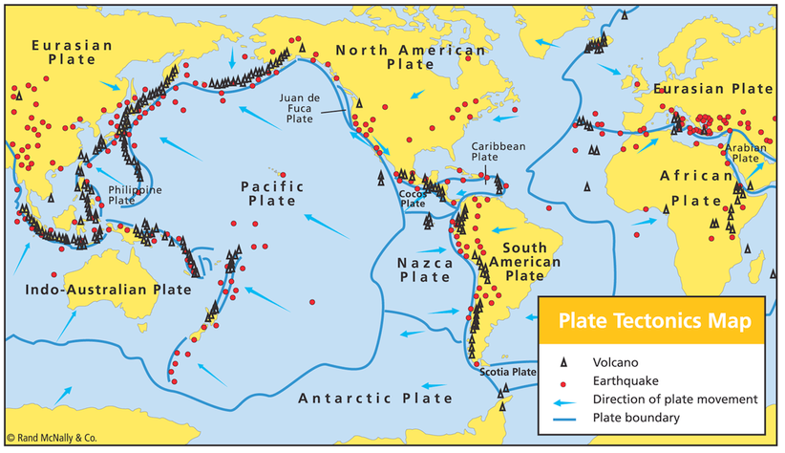

**Key Words**

**Atmospheric hazards** – Due to weather and climate.

**Geological hazards** – Due to plate tectonic movement.

**Convection current** – The currents in the mantle as the hot less dense molten rock rises and cools.

**Plate boundary** – The boundary or margin between two tectonic plates.

**Volcano** – An opening in the Earth’s crust from which lava, ash and gases erupt.

**Pyroclastic flow** - A fast-moving current of hot gas and volcanic matter

**Earthquake** – A sudden or violent movement within the Earth’s crust followed by a series of shocks.

Constructive

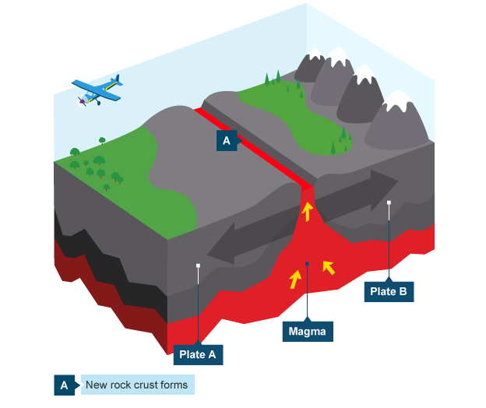

* Convection currents 🡪 Two plates move away
* New land formed
* Earthquake, shield volcano
* E.g. Mid-Atlantic ridge, Eurasian and North American plate, Iceland.

Destructive

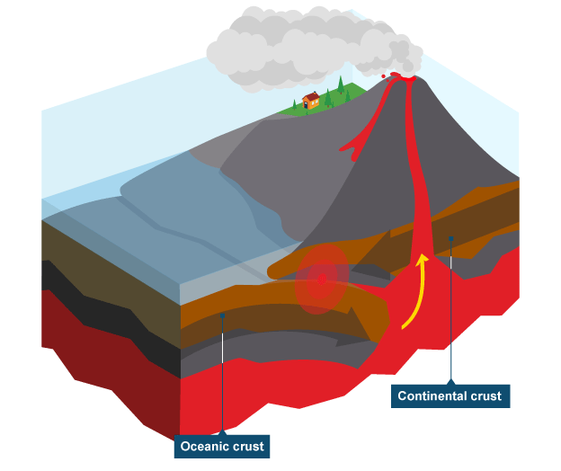

* Convection currents 🡪 Oceanic subducts under continental
* Melts, less dense 🡪 magma rises
* Earthquake, composite volcano, trench
* E.g. Atacama Trench, Nazca and South American plates.

Collision

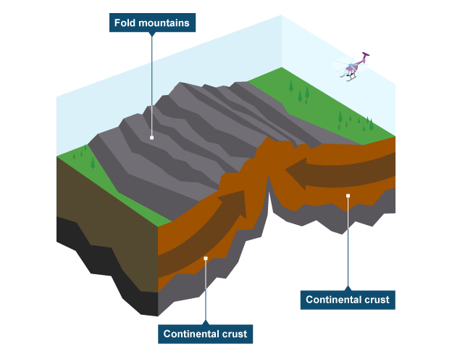

* Convection currents 🡪 Plates moving towards each other.
* Earthquakes, fold mountains
* E.g. Himalayas, Indo-Australian and Eurasian plate, India.

Conservative

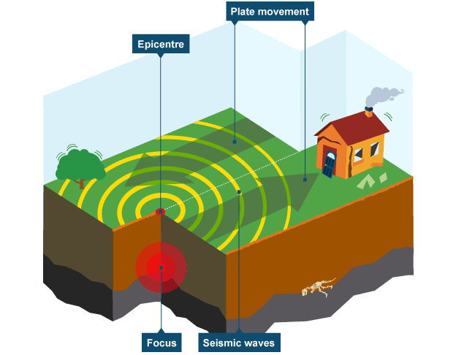

* Convection currents 🡪 Plates moving opposite ways, or different speeds
* Earthquakes
* E.g. San Andreas Fault, Pacific and North American plates.

**LIC – Haiti (CASE STUDY)**

2010, Conservative plate boundary – North American and Caribbean plate, magnitude 7.0, epicentre 10 miles from Port au Prince, shallow focus – 13km below surface.

|  |  |
| --- | --- |
| Primary Effects | Secondary Effects |
| 230,000 people died | Cholera broke out in refugee camps |
| 100,000 houses destroyed | 1 in 5 jobs were lost |
| 19 million cubic metres of rubble in Port au Prince | Political confusion |
| 60% government buildings destroyed | 1.5 million people became homeless |
| 8.5 billion dollars’ worth of damage |  |

|  |  |
| --- | --- |
| Immediate Responses | Long-term Responses |
| Charities and governments sent hundreds of thousands of tents for victims to live in. | Christian Aid built 300 earthquake resistant homes that flex to absorb waves. |
| Governments loaned cranes and diggers to move 10 million tonnes of debris. | Charities funded education programmes, teaching people about hygiene after a quake. |
| The Dominican Republic sent medical units and 36 doctors and surgeons. | Construction teams have been trained to build sturdy houses and buildings. |

**HIC – Japan (CASE STUDY)**

2011, Destructive plate boundary – Eurasian and pacific plate, magnitude 9.0, tsunami, epicentre 100km from Sendai.

|  |  |
| --- | --- |
| Primary Effects | Secondary Effects |
| 16,000 people died | 3 meltdowns at the Fukushima nuclear power plant released radioactive materials |
| 4 million left without electricity |
| Caused 400km of coastline to drop by 1.6 meters | Toyota and Sony stopped production due to the earthquake |
| 300 billion dollars’ worth of damage |

|  |  |
| --- | --- |
| Immediate Responses | Long-term Responses |
| The JSDF cleared the debris within 2 days. | Future planning against tsunamis. |
| Infrastructure such as the airport was back and running within days (Haiti a month). |  |
| Evacuation at Fukushima. | Fukushima was shut down to protect environment and surroundings. |
| Countries such as the UK sent search and rescue teams to find survivors. |

Protection

* HICs have rubber and mesh shock absorbers at the foundation of buildings that absorb the waves.
* LICs have bamboo.
* A counter-weight Pendulum is used at the top of tall buildings to prevent collapse.
* Buildings held together by steel frames.
* Automatic window shutters to prevent broken glass injuring people.

Monitoring

**Earthquakes**

Earthquakes can be monitored through **Seismometers** which monitor the seismic waves that are produced by plate movement. **Lasers** can also track the movement of plates. **Radon gas levels** can be monitored as this gas can escape from cracks in the plate boundaries.

**Volcanoes**

Earthquakes preceding an eruption can be measured by **seismometers**. **Thermal imaging** can be used to detect if a volcano is getting warmer. **Gas sampling of sulphur** and monitoring is also useful.

Prediction

**Earthquakes**

Earthquakes are very hard to predict because they can happen at any point on the plate boundary. Scientists can forecast where they may occur based on plate movement that can be monitored by lasers and seismometers.

**Volcanoes**

Volcanic eruption is much easier to predict if they are closely monitored. For example, seismometers can pick up tiny earthquakes that occur before an eruption and high levels of sulphur can also indicate this.

Preparation

* Developing an emergency plan and creating exclusion zones.
* Teaching family and children to call emergency lines.
* Emergency supplies stockpiled.
* Preparing for aftershocks.
* Fastening items to walls.
* IF INSIDE take cover under stable furniture and away from glass.
* IF OUTSIDE find a clear spot away from builings.

**Why do people live in areas affected by hazards?**

Fertile Soils

* Soils in volcanic areas are extremely fertile due to the weathering of volcanic products such as ash, lava, and rock, which release valuable nutrients that enrich the soil.
* E.g. The slopes of Vesuvius in Italy have soils that provide agricultural benefits

Geothermal

* In Volcanic areas the heat from the magma can be harnessed to produce electricity and provide energy to the local area by pumping down cold water that is turned to steam.
* E.g. There are geothermal power plants in Iceland

Tourism

* Volcanic scenery often draws tourists which also provides other business opportunities such as cafes and shops in the local area. This is a huge economic benefit to the country/town.
* E.g. Old Faithful geyser in Yellowstone national park

Minerals

* Minerals such as copper and gold are found in volcanic areas as they are associated with the rising magma which may cool and harden beneath the volcano. This is very good for mining businesses and improving local economy through job opportunities.
* E.g. Mexico