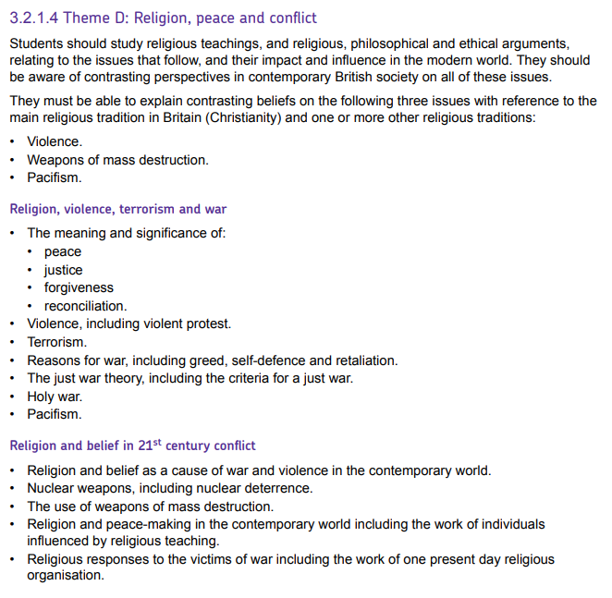

Theme D – Religion, peace and conflict
Justice This means fairness, making right a fair situation which has been unjust.
CHRISTIAN views | MUSLIM views
It is important that when a crime is committed there is justice, it needs to be fair. Christians will fight for justice under the conditions of the just war theory. War does go against Jesus’ teachings, but it is necessary for the greater good. | They believe in Jihad, ‘the striving for justice’, which can mean armed conflict to protect the common good. Wars have to be carried out in the right way and there are set rules for warfare. Allah is the source of all justice, ‘avoid being unjust to one another’ (Hadith),

Forgiveness and reconciliation
Reconciliation: Making up between two groups/sides after disagreement.
Forgiveness: Letting go of blame against a person for wrongs they have done
- Jesus died on the cross to bring forgiveness and reconciliation.
- Reconciliation is a sacrament in the Catholic Church.
- Mission of Church is to proclaim Jesus came to reconcile the relationship between God and humans.
- Christians should always work to reconcile after conflicts. In the Bible, Jesus taught ‘blessed are the peacemakers, they will be called the children of God’
- All people need to be reconciled to God. Christians believe that Jesus could die so that our sin could be forgiven, and we could be reconciled to God.
- When Peter asked to forgive his brother up to seven times, Jesus said he should forgive 77 times.
- The Lord’s prayer states that Christians should forgive others in order to be forgiven by God.
- The power of forgiveness and love (agape) can lead to the ending of conflict.
- Forgiveness in Islam is conditional. A human must be sorry, recognise the wrong, commit to not repeat it, and seek forgiveness. Mount Arafat is a hill during Hajj pilgrimage where Muslims go to reflect and ask for forgiveness.
EXAMPLES:
Corrie Ten Boom – a Dutch girl and was able to forgive her concentration camp guard.
Eric Lomax – a British soldier who was able to forgive his torturer during WW2.

Protest, Violence and Terrorism
Protest: a demonstration of disapproval often in a public group. Violence: using actions that threaten or cause actual harm to a person. Terrorism: is an act of violence that is intended to create fear.
CHRISTIAN | MUSLIM
Jesus taught that violence is counterproductive. Violence encourages retaliation and so makes the situation worse.  ‘Blessed are the peacemakers’  ‘Put away your sword. Those who live by the sword die by the sword’ (Matthew 26:52) | ‘If anyone slays a person…it would be as if he slew all people.’  Violence is never right ‘unless it be for murder or for spreading mischief’
Quakers would argue that a Christian should follow the example of Jesus and ‘Love thy neighbour’, violent actions are not loving and therefore always wrong.
Violence may be justified as a last resort. It may be the only way to get rid of a corrupt regime and restore justice. In protest at the misuse of the Temple, Jesus ‘overturned the tables of the money changers and the benches of those selling doves’. | Fighting is allowed in certain circumstances.  ‘Fight in the cause of God against those who fight you,’
The Roman Catholic Church stance is that there is a dignity to being human. Inflicting violence on them or receiving it is a denial of that dignity. Pope Francis has spoken out against the death penalty.

Reasons for War War: fighting, usually between nations, to resolve conflicts and issues between them.
Greed | Self defence | Retaliation
Historically many wars have been fought for land, money, power and resources. In the modern world this is generally not seen as a good reason for going to war. “For the love of money is the root of all evil” (Bible) | Most people consider fighting to defend your  own country morally acceptable. The UK fought in the Second World War against Nazi aggression to prevent Britain being invaded. | If a war is started in response to an act of aggression. In 2001 the USA declared war on Afghanistan in response to the 9/11 terrorist attacks. “Do not repay anyone evil for evil” “An eye for an eye”

WMD and War
WMD: Weapons of Mass Destruction
Agree with the use of WMD | Disagree with the use of WMD
The Roman Catholic Church thinks they are acceptable as a deterrent  Countries that possess them are unlikely to attack each other  Makes a country vulnerable if they are disposed of altogether  “Lesser of two evils” “Eye for an eye” | Possession poses a risk to humanity  Destruction caused cannot be justified for any reason  Use goes against all principles of the ‘Just War’  All religions oppose the use of them and support disarmament “Love thy neighbour” “Do not kill”  Quakers condemn WMD since they are pacifists, and no outward weapons are acceptable. They are indiscriminate and beyond control
CHRISTIAN views on going to war | MUSLIM views on going to war
Christians may support the limited use of violence in some cases to force change for the common good.  ‘An eye for an eye’ (Old Testament, Bible) | Muslims believe that in a conflict with another nation, if talking does not sort out the problem then war is a religious duty for a Muslim. Lesser jihad is a holy war in defence of Islam. Some believe that if they fight for Allah, they’ll be rewarded in the afterlife ‘We will bestow upon him a great reward’. (Q)
Jesus was a pacifist and taught non-violence and against war in every circumstance. ‘Turn the other cheek’ | Muslims great each other with the words ‘salaam alaikum’ which means ‘peace be upon you.’ Allah also teaches ‘Allah does not like the transgressors’

Just War Theory and Holy War
Just War: believing it is right to fight war in the interests of justice and the greater good.
Holy War: believing it is right to fight a war in the name of God.
 | CHRISTIAN | MUSLIM
Holy War | They were authorised by God or by a spiritual leader and because of this those who take part will receive a reward such as going to Heaven when they die. Joshua’s army followed God’s commands to blow trumpets and bring down the walls of Jericho. | ‘Fight in the cause of God against those who fight you,’  For Muslims, a holy war is a just war (lesser jihad) and if attacked, defensive war becomes a religious duty for Muslims. They have rules on who fights, how the war is fought and how it ends.

Just War Theory Rules
(a war that the Christian Church defines as acceptable)
- Just cause
- Last resort
- Proper authority
- Reasonable chance of success
- Intent to establish good
- Avoid killing civilians
- Force proportional to cause
- Good outcome
‘It is impossible to conceive of a just war in a nuclear age.’ Pope John

Consequences of War
- Injuries and death
- Cost
- Victory/Defeat
- Contamination of land and water
- Famine and disease
- Destruction of buildings and land
Helping
- Provide food and shelter
- medical help
- help to rebuild their lives
- work to create peace

Helping the victims of War
- Helping victims of war fits with the basic teaching of the Golden Rule ‘Treat others as you would like them to treat you’, which every religion follows.
- In Islam, the Golden Rule states ‘None of you truly believe until he wishes for his brothers what he wishes for himself’.
- CAFOD – helping to rehabilitate children who have fought as soldiers in war, offering them education, counselling and support, providing refugees fleeing conflict with emergency aid, such as food, shelter and cooking equipment
- Christian Aid – Aim to bring an end to poverty. Work with the victims. Establish basic human rights and fairness in society. Support the local organisations to help deal with the issues. Raise awareness of conflict around the world. Fundraise through Christian Aid week. Distribute envelopes with a donation inside.
- Islamic Relief – Independent charity which respond to the needs of victims by providing short term aid during disasters and emergencies/. Inspired by their faith and the teaching of Islam. Allocate resources regardless of race, politics, gender or belief. Expect nothing in return. Follow the teaching ‘whoever saved a life, it would be as if they saved the life of all mankind’. Qur’an 5:32.
- Jesus commanded Christians to ‘love their neighbour’. ‘Your neighbour’ means everyone, so Christians should help victims of war.
- The Parable of the Good Samaritan and the Parable of the Sheep and Goats encourages Christians to provide food and shelter for those in need

Religion and War – Does religion cause wars?
YES | NO
Some Muslims have claimed that the Gulf Wars and the troubles in Israel and Palestine are because the West were, or still are, making a direct attack on Islam. | All religions speak of peace not war, especially with people or nations of the same religion.
Religion may not be a cause directly, but often the defining factor. Israel and Palestine is an issue over land and living conditions yet it is often seen as between Jewish and Muslim people. | It is truer to say that religion rises to the surface in conflicts whereas power, land, and self-defence are the real causes. War creates tensions and religious divisions surface. Also, people claim religion as the cause to get support from people of the same religion around the world.

Peace and Pacifism
A pacifist is a person who believes that war and violence can rarely be justified. Conflicts should be settled in a peaceful way. Pacifists strongly believe that it is best to work at preventing war from becoming a possibility. They believe it is even wrong to fight in self-defence. Humans’ lives are so valuable that nothing can justify putting them under threat.
- Not all Christians are pacifists; some think war can be justified on some occasions.
- Peace can be achieved through religious faith, supported by prayer and meditation.
- Conscientious objectors are people who refuse to directly fight in wars on the grounds of conscience.
- Many pacifists take their inspiration from Jesus, who taught non-violence. They believe to follow non-violence is to follow the way of Jesus.

Quaker opinion | Anglican opinion | Islam opinion
The Quaker Society is pacifist. They do not join armies and refuse to participate in any violence. They are committed to peace making. As Jesus was a pacifist and said ‘Blessed are the peacemakers, for they shall be called children of God’ Their Peace Testimony makes clear that they will not use violence under any circumstances. During wars, they will take on peace-making roles, for example, mediate for peace between the warring nations. They also do non-combat work such as training to be, and acting as medics for any side, and doing work with refugees and victims of war. | The Church of England is not a consistently pacific church. It is clear that soldiers have been supported and are honoured. The Church accepts the Just War Theory, and sees war as necessary in certain conditions, especially in situations where war is waged to fight injustice. When pacifist methods seem not to have made a difference, then war may be sanctioned. In WW2, for example, Anglican chaplains served in all the armed forces units | Islam is a religion of peace. It is difficult for Muslims to call themselves pacifists because of the duty of Jihad. In most circumstances Muslims share principles of pacifism and sympathise with the cause of pacifists. Muslims believe being at peace with yourself helps you to avoid conflict.  They believe inner peace comes from submitting your life to God and becoming part of the Ummah, which gives them solidarity and support.  The word ‘Islam’ comes from the root word ‘salaam’ meaning ‘peace’

Working for Peace
- Pope Francis – He promotes equality through peaceful methods of negotiation to ensure that all people get the treatment they deserve. He emphasises that peace is all one person needs in order to respect other’s opinions and views. ‘initiatives in favour of peace’ ‘view others as valid dialogue’
- The Dalai Lama – He is the spiritual leader of Tibetan Buddhists. He is recognised around the world as a symbol of peace and believes peace will only exist when everyone respects each other. He received the Nobel Peace Prize in 1992 and has maintained peaceful protests against Chinese rule.

Ways religious believers can work for peace
- Give their time by protesting against war
- Pray that God will bring peace to the world
- Join a religious organisation that campaigns for peace eg The Anglican Pacifist Fellowship
- Fight a war to bring peace

